Front-End Notes

- Notes :Day 1
  - Fullscreen

1. Notes (with Examples)

What is HTML?
  - HTML (HyperText Markup Language) is the standard language used to create webpages.
  - It uses tags (or elements) to structure content.
  - Each HTML file is a plain text document that tells the browser how to display text, images, links, etc.

Basic Structure of an HTML Document
Every HTML page follows this basic layout:

<!DOCTYPE html>
<html>
<head>
<title>My First Webpage</title>
</head>
<body>
<h1>Welcome to My Website</h1>
<p>This is my first HTML page!</p>
</body>
</html>

Explanation of Each Part:
  - <!DOCTYPE html>
    - Declares the document type.
    - Tells the browser this is an HTML5 document.
    - Must be the first line in any HTML file.
  - <html> Element
    - The root element of an HTML page.
    - All content (head + body) is placed inside <html>...</html>.
  - <head> Element
    - Contains meta information about the page (not displayed directly).
    - Examples: title, links to CSS, scripts, SEO data, etc.
    - Common head elements:

<head>
<meta charset="UTF-8">
<meta name="description" content="Learning HTML">
<title>Introduction to HTML</title>
</head>

  - <body> Element
    - Contains all the visible content shown on the webpage.
    - Example:

<body>
<h1>Hello, world!</h1>
<p>This text appears on the page.</p>
</body>

Root, Container, and Child Elements

1. Root Element
  - The top-most element that contains all other HTML elements.
  - In every HTML page, the root element is <html>.
  - Example:

<html>
<!-- Everything inside this is part of the root -->
</html>

2. Container Elements
  - Elements that hold or wrap other elements.
  - They “contain” child elements inside them.
  - Examples: <div>, <section>, <article>, <header>, <footer>, etc.
  - Example:

<div>
<h2>About Me</h2>
<p>I am learning HTML.</p>
</div>

Here, <div> is the container element.

3. Child Elements
  - Elements that are nested inside another element.
  - They are “children” of the parent container.
  - Example:

<div>
<h2>Title</h2>
<p>This is a paragraph inside a div.</p>
</div>

    - <div> = Parent
    - <h2> and <p> = Child elements

Element Hierarchy Example

<!DOCTYPE html>
<html>
<head>
<title>HTML Structure Example</title>
</head>
<body>
<div>
<h1>Learning HTML</h1>
<p>HTML helps create the structure of a webpage.</p>
</div>
</body>
</html>

Hierarchy Summary:
  - <html> → Root element
  - <head> and <body> → Child elements of <html>
  - <div> → Container element inside <body>
  - <h1> and <p> → Child elements of <div>

- Notes - Day 2
  - Fullscreen

1. Notes (with Examples)

🧩 Block-level Elements

Definition:
  - Block-level elements start on a new line and take up the full width available.
  - They create a visible “block” on the webpage.
  - Common examples:
<div>, <p>, <h1>–<h6>, <section>, <article>, <header>, <footer>, <ul>, <ol>, <table>

Characteristics:
  - Always start on a new line.
  - Can contain inline or other block-level elements.
  - Automatically stretch to fill their parent container’s width.

Example:

<body>
<h1>This is a Heading</h1>
<p>This is a paragraph inside the body. It is a block-level element.</p>
<div>
<p>Even this paragraph is inside a block-level container (div).</p>
</div>
</body>

🗒️ In this example, each element starts on a new line and forms its own block.

💬 Inline Elements

Definition:
  - Inline elements do not start on a new line.
  - They only take up as much width as their content needs.
  - Common examples:
<span>, <a>, <strong>, <em>, <b>, <i>, <img>, <label>

Characteristics:
  - Stay within the same line as surrounding content.
  - Usually used inside block elements.
  - Cannot contain block-level elements inside them.

Example:

<p>This is a <strong>bold</strong> word and this is <em>italic</em>.</p>
<p>Visit <a href="https://www.example.com">our website</a> for more details.</p>

🗒️ Here, <strong>, <em>, and <a> are inline — they appear in line with the text, not on new lines.

⚖️ Comparison: Block vs Inline
Feature | Block-level Elements | Inline Elements
Starts on a new line? | Yes | No
Width | Full width of the container | Only as wide as content
Can contain block elements? | Yes | No
Examples | <div>, <p>, <h1> | <span>, <a>, <b>
Typical Use | Structure and layout | Styling or emphasizing text

🌐 Common HTML Tags (You’ll Use All the Time)

1. Headings (<h1>–<h6>)
  - Used to define headings or titles.
  - <h1> is the most important; <h6> is the least.
  - Example:

<h1>Main Heading</h1>
<h2>Subheading</h2>

2. Paragraph (<p>)
  - Defines a block of text.

<p>This is a paragraph of text.</p>

3. Link (<a>)
  - Used to create hyperlinks.

<a href="https://www.google.com">Visit Google</a>

4. Image (<img>)
  - Displays an image on the page.

<img src="photo.jpg" alt="A beautiful photo">

  - The alt attribute describes the image (important for accessibility).

5. Line Break (<br>)
  - Creates a single line break.

<p>Hello<br>World!</p>

6. Horizontal Rule (<hr>)
  - Draws a horizontal line (used to separate content).

<hr>

7. Division (<div>)
  - A block-level container used to group content.

<div>
<h2>About Me</h2>
<p>I love web development.</p>
</div>

8. Span (<span>)
  - An inline container used to style or group text inline.

<p>This is <span style="color:red;">important</span> text.</p>

9. Lists
  - Ordered List (<ol>) – numbered
  - Unordered List (<ul>) – bulleted
  - List Item (<li>) – defines each list entry

<h3>My Favorite Foods</h3>
<ul>
<li>Pizza</li>
<li>Burger</li>
<li>Ice Cream</li>
</ul>

🧠 Summary:
  - Block-level elements = take full width, start on new lines.
  - Inline elements = stay in the same line, only as wide as content.
  - Common tags include headings, paragraphs, links, images, lists, and containers.
  - Understanding this helps you organize and design webpages effectively.

- Notes Day 3
  - Fullscreen

🧩 What are Semantic Tags?
Definition:
Semantic tags are HTML elements that describe the meaning or purpose of the content they contain.
For example:

<header> represents the top section
<main> represents the main content
<footer> represents the bottom section

So instead of writing:

<div id="header"> ... </div>

You can use:

<header> ... </header>

🧠 Why Use Semantic Tags?
  - Makes your HTML easier to read and maintain.
  - Helps search engines understand your page structure.
  - Assists screen readers for visually impaired users.
  - Creates consistent structure across websites.

🏗️ Common Semantic Tags
Tag | Meaning | Typical Use
<header> | Top section or heading area | Contains logo, navigation, or intro
<nav> | Navigation section | Contains links to other pages or sections
<main> | Main content area | Holds the central content of the page
<section> | A section of related content | Used to group similar topics
<article> | Independent content | Blog post, news story, or article
<aside> | Sidebar or extra info | Related but not part of main flow
<footer> | Bottom section | Copyrights, contact info, links
<figure> | Used for media with caption | Contains images, diagrams, etc.
<figcaption> | Caption for <figure> | Describes the media
<time> | Represents date/time | Shows time or date values

📘 Example: Simple Semantic Web Page

<!DOCTYPE html>
<html lang="en">
<head>
<meta charset="UTF-8">
<title>Semantic HTML Example</title>
</head>
<body>

<header>
<h1>My Blog</h1>
<nav>
<a href="#home">Home</a> |
<a href="#articles">Articles</a> |
<a href="#contact">Contact</a>
</nav>
</header>

<main>
<section id="articles">
<article>
<h2>Understanding Semantic HTML</h2>
<p>Semantic tags make web pages easier to understand by both developers and search engines.</p>
</article>
</section>

<aside>
<h3>Quick Links</h3>
<ul>
<li><a href="#">HTML Basics</a></li>
<li><a href="#">CSS Intro</a></li>
</ul>
</aside>
</main>

<footer>
<p>&copy; 2025 My Blog. All rights reserved.</p>
</footer>

</body>
</html>

🧠 Explanation of the Example
  - <header> → Top part of the page with title and navigation.
  - <nav> → Navigation links section.
  - <main> → Holds the main visible content.
  - <section> → Groups related content (like all articles).
  - <article> → Individual post or content piece.
  - <aside> → Sidebar with extra links.
  - <footer> → Bottom part with copyright text.

🧱 Visual Layout Summary

-----------------------------------------------------
| HEADER |
| (Logo, Navigation) |
-----------------------------------------------------
| MAIN CONTENT AREA | ASIDE (Sidebar) |
| <article>, <section> | Extra Info |
-----------------------------------------------------
| FOOTER |
| (Contact, Copyright) |
-----------------------------------------------------

🌐 More Semantic Elements in HTML5
Tag | Description | Example Use
<figure> | Wraps an image or diagram | <figure><img src="pic.jpg"><figcaption>Caption</figcaption></figure>
<figcaption> | Caption for figure | Describes the image
<mark> | Highlights text | <p>This is <mark>important</mark>!</p>
<time> | Represents a time/date | <time datetime="2025-10-27">October 27, 2025</time>
<details> / <summary> | Collapsible section | <details><summary>Read More</summary><p>Hidden text...</p></details>

- Day 4- Notes
  - Fullscreen

Notes (with Examples)

7.1 Creating a Basic Table

Definition:
Tables are defined using the <table> tag, and rows & cells are created using <tr> and <td>.

Basic Syntax:

<table>
<tr>
<td>Row 1, Cell 1</td>
<td>Row 1, Cell 2</td>
</tr>
<tr>
<td>Row 2, Cell 1</td>
<td>Row 2, Cell 2</td>
</tr>
</table>

Output:
A simple 2×2 table.

7.2 Table Headers, Rows, and Cells
Tag | Description
<table> | Defines the table
<tr> | Table row
<th> | Header cell (bold + centered by default)
<td> | Data cell

Example:

<table border="1">
<tr>
<th>Student Name</th>
<th>Grade</th>
</tr>
<tr>
<td>Ali</td>
<td>A</td>
</tr>
<tr>
<td>Sara</td>
<td>B+</td>
</tr>
</table>

🗒️ Note: The border attribute adds a border around the table for visibility.

7.3 Spanning Rows and Columns (rowspan, colspan)

Definition:
  - colspan → Merges columns horizontally.
  - rowspan → Merges rows vertically.

Example:

<table border="1">
<tr>
<th rowspan="2">Name</th>
<th colspan="2">Marks</th>
</tr>
<tr>
<th>Math</th>
<th>Science</th>
</tr>
<tr>
<td>Ali</td>
<td>90</td>
<td>85</td>
</tr>
</table>

🧠 Explanation:
  - rowspan="2" makes one header span two rows.
  - colspan="2" makes one header span two columns.

7.4 Table Styling with Attributes
You can style tables using basic attributes or CSS later (for now, we use attributes).
Attribute | Description | Example
border | Adds table borders | <table border="1">
cellpadding | Adds space inside cells | <table cellpadding="5">
cellspacing | Adds space between cells | <table cellspacing="5">
width | Sets table width | <table width="60%">
align | Aligns table (deprecated, use CSS later) | <table align="center">

Example:

<table border="1" width="60%" cellpadding="8" cellspacing="3" align="center">
<tr>
<th>Subject</th>
<th>Marks</th>
</tr>
<tr>
<td>HTML</td>
<td>95</td>
</tr>
<tr>
<td>CSS</td>
<td>88</td>
</tr>
</table>

🧠 Summary Table
Concept | Tag / Attribute | Description
Table | <table> | Creates the table
Row | <tr> | Table row
Header | <th> | Header cell
Cell | <td> | Data cell
Merge Columns | colspan | Span multiple columns
Merge Rows | rowspan | Span multiple rows
Style | border, cellpadding, width, etc. | Adjusts appearance

Day 5:

Summary of Today’s Lesson
- Forms collect user input through various input types.
- Use <form> with the right method and enctype.
- text, email, number, date, file, checkbox, select, and textarea are key form controls.
- Always label your fields clearly and use alt text or placeholders to improve usability.
Today we’re going to learn how to collect user information using HTML forms.
Forms are one of the most important parts of web development — they allow users to enter data like names, emails, and attachments.
We’ll explore different input types such as text, number, email, date, file uploads, dropdowns, checkboxes, and textareas.
By the end of this class, you’ll be able to build a complete Student Admission Form that looks professional and functional.
- Forms Notes HTML
  - Fullscreen

🧩 1️⃣ What is an HTML Form?
An HTML form is used to collect user input.
It starts with the <form> tag and includes form controls like <input>, <select>, <textarea>, etc.

Basic Structure:

<form action="submit.html" method="post">
<!-- form elements go here -->
</form>

Attribute | Description
action | The page or script where data is sent.
method | GET or POST (POST is used for forms that send data securely).

🧱 2️⃣ Common Form Elements
Element | Description | Example
<input type="text"> | Text field | <input type="text">
<input type="number"> | Number input | <input type="number">
<input type="date"> | Date picker | <input type="date">
<input type="email"> | Email input | <input type="email">
<input type="file"> | File upload | <input type="file">
<select> | Dropdown list | <select><option>...</option></select>
<textarea> | Multi-line text box | <textarea></textarea>
<input type="checkbox"> | Checkbox | <input type="checkbox">
<input type="radio"> | Radio buttons | <input type="radio" name="gender">
<input type="submit"> | Submit button | <input type="submit" value="Submit">

🧾 Example: Student Admission Form
Here’s your complete form built exactly from your listed fields 👇

<!DOCTYPE html>
<html lang="en">
<head>
<meta charset="UTF-8">
<title>Student Admission Form</title>
</head>
<body>
<h1>Student Admission Form</h1>

<form action="submit.html" method="post" enctype="multipart/form-data">

<label>Photo:</label>
<input type="file" name="photo"><br><br>

<label>Full Name:</label>
<input type="text" name="fullname" required><br><br>

<label>Age:</label>
<input type="number" name="age" min="1" max="100"><br><br>

<label>Date of Birth:</label>
<input type="date" name="dob"><br><br>

<label>Attach Birth Certificate:</label>
<input type="file" name="birth_certificate"><br><br>

<label>Gender:</label>
<select name="gender">
<option value="">--Select--</option>
<option>Male</option>
<option>Female</option>
<option>Other</option>
</select><br><br>

<label>Nationality:</label>
<select name="nationality">
<option value="">--Select--</option>
<option>Indian</option>
<option>American</option>
<option>British</option>
<option>Other</option>
</select><br><br>

<label>Religion:</label>
<input type="text" name="religion"><br><br>

<label>Community / Caste:</label>
<input type="text" name="community"><br><br>

<label>Aadhar Card Number:</label>
<input type="number" name="aadhar"><br><br>

<label>Phone:</label>
<input type="number" name="phone"><br><br>

<label>Email:</label>
<input type="email" name="email"><br><br>

<label>Address:</label><br>
<textarea name="address" rows="3" cols="30" placeholder="Temporary / Permanent Address"></textarea><br><br>

<label>Parents / Guardians:</label><br>
<input type="checkbox" name="parent_type" value="Father"> Father
<input type="checkbox" name="parent_type" value="Mother"> Mother
<input type="checkbox" name="parent_type" value="Guardian"> Guardian
<br><br>

<label>Parent's Phone:</label>
<input type="number" name="parent_phone"><br><br>

<label>Parent Occupation:</label>
<input type="text" name="occupation"><br><br>

<label>Sibling Studying in the Same School:</label>
<input type="text" name="sibling"><br><br>

<label>Annual Income:</label>
<input type="number" name="income"><br><br>

<label>Medical Issue / Disability:</label>
<select name="medical_issue">
<option value="">--Select--</option>
<option>Yes</option>
<option>No</option>
</select><br><br>

<label>Blood Group:</label>
<select name="blood_group">
<option value="">--Select--</option>
<option>A+</option>
<option>A-</option>
<option>B+</option>
<option>B-</option>
<option>O+</option>
<option>O-</option>
<option>AB+</option>
<option>AB-</option>
</select><br><br>

<label>Add Transfer Certificate (TC):</label>
<input type="file" name="tc"><br><br>

<label>Identification Marks:</label>
<input type="text" name="id_marks"><br><br>

<label>Extra-Curricular Activities:</label>
<input type="text" name="activities"><br><br>

<label>Mother Tongue:</label>
<select name="mother_tongue">
<option value="">--Select--</option>
<option>English</option>
<option>Hindi</option>
<option>Tamil</option>
<option>Telugu</option>
<option>Malayalam</option>
<option>Other</option>
</select><br><br>

<input type="submit" value="Submit Form">
<input type="reset" value="Reset">

</form>
</body>
</html>

🧠 Explanation of Key Concepts
Element | Purpose
<form> | Wraps all form elements.
<input> | Used for text, numbers, dates, emails, files, etc.
<textarea> | Used for multi-line input like address.
<select> and <option> | Dropdown menus.
<checkbox> | Allows multiple selections.
<file> | Upload files.
<submit> and <reset> | Send or clear form data.
enctype="multipart/form-data" | Required when file uploads are included.

Day 6

Today we’ll learn what CSS is, why it’s important in web development, and how to apply it using inline, internal, and external styles.
We’ll also explore selectors, properties, and values — the foundation of all CSS styling.
- Notes
  - Fullscreen

1.1 What is CSS?
CSS (Cascading Style Sheets) is a language used to style HTML elements.
It describes how HTML content should look — including colors, fonts, spacing, alignment, and layout.

Example:

<p style="color: blue; font-size: 20px;">This is styled text!</p>

🧠 CSS tells the browser:
“Display this text in blue, with a font size of 20 pixels.”

1.2 Role of CSS in Web Development
CSS separates content (HTML) from presentation (style).
This makes your code:
  - Easier to read and maintain
  - Faster to update (change one file → update all pages)
  - More attractive and responsive

Without CSS:
A plain webpage with no colors or spacing 😢

With CSS:
Beautiful, consistent design 🎨
Example:

<h1 style="color: #2E8B57; text-align: center;">Welcome to My Website</h1>
<p style="font-family: Arial; color: #333;">This page looks so much better with CSS!</p>

1.3 Types of CSS
There are three main ways to add CSS to your HTML file.

A. Inline CSS
  - Written inside the HTML tag using the style attribute.
  - Affects only that single element.
Example:

<p style="color:red; font-size:18px;">This text is red and 18px in size.</p>

🧠 Use only for small, one-time styling.

B. Internal CSS
  - Written inside the <style> tag within the <head> section of your HTML file.
  - Affects the entire page.
Example:

<!DOCTYPE html>
<html>
<head>
<style>
body {
background-color: #f2f2f2;
font-family: Arial;
}
h1 {
color: blue;
text-align: center;
}
</style>
</head>
<body>
<h1>Hello World</h1>
</body>
</html>

C. External CSS
  - Written in a separate .css file and linked using <link> in the <head>.
  - Best for large projects or multiple pages.
Example (index.html):

<link rel="stylesheet" href="style.css">

Example (style.css):

body {
background-color: #eef;
}
h1 {
color: darkblue;
}

🧠 External CSS is preferred for scalability and clean structure.

1.4 CSS Syntax and Selectors Overview

Basic CSS Syntax:

selector {
property: value;
}

Example:

p {
color: green;
font-size: 18px;
}

🧠 This means:
For every <p> element, make the text green and 18 pixels tall.

CSS Basics: Properties, Values, and Selectors

1️⃣ Properties
These define what aspect of the element you want to style — e.g., color, font-size, background-color, border, etc.

2️⃣ Values
These are how you want that property to look — e.g., red, 20px, center, solid.
Example:

h1 {
color: red;
text-align: center;
font-size: 24px;
}

3️⃣ Selectors
Selectors target specific elements to style them.
The most common ones are:
Selector Type | Symbol | Example | Description
Element Selector | none | p { color: blue; } | Styles all <p> elements
Class Selector | . | .highlight { color: red; } | Styles elements with class="highlight"
ID Selector | # | #mainTitle { font-size: 30px; } | Styles the element with id="mainTitle"

Example: Using Element, Class, and ID Selectors

<!DOCTYPE html>
<html>
<head>
<style>
/* Element Selector */
p {
color: darkgreen;
}

/* Class Selector */
.highlight {
background-color: yellow;
font-weight: bold;
}

/* ID Selector */
#title {
color: navy;
text-align: center;
font-size: 28px;
}
</style>
</head>
<body>
<h1 id="title">Welcome to CSS Learning</h1>
<p>This is a normal paragraph.</p>
<p class="highlight">This paragraph is highlighted using a class!</p>
</body>
</html>

🧠 Quick Comparison Table
Type | Symbol | Example | Usage
Element Selector | none | p {} | Targets all elements of that type
Class Selector | . | .intro {} | Targets elements with a specific class
ID Selector | # | #header {} | Targets one unique element

Day 7:

- Notes - Teaching
  - Fullscreen

Notes (Definitions + Explanations)

1.1 What is the CSS Box Model?
  - The CSS Box Model describes how elements are displayed and how space is distributed around them.
  - Each element is treated as a rectangular box made up of four parts.
The 4 Layers (inside to outside):
  - Content: The actual text, image, or other content inside the element.
  - Padding: Space between the content and border.
  - Border: The outline surrounding the content and padding.
  - Margin: Space outside the border, separating the element from others.

1.2 Box Model Diagram

+-----------------------------+
| Margin |
| +-----------------------+ |
| | Border | |
| | +-----------------+ | |
| | | Padding | | |
| | | +-----------+ | | |
| | | | Content | | | |
| | | +-----------+ | | |
| | +-----------------+ | |
| +-----------------------+ |
+-----------------------------+

1.3 Box Model Properties
Property | Description | Example
margin | Controls the space outside the element | margin: 20px;
padding | Controls the space inside the element, around content | padding: 10px;
border | Defines the outline around content and padding | border: 2px solid black;
width / height | Set the size of the content area | width: 200px; height: 100px;

1.4 box-sizing Property
  - By default, width and height apply only to the content area.
  - To include padding and border in total size, use:

box-sizing: border-box;

✅ This ensures total element size stays consistent.

2. Class Examples (with teaching notes)

🧩 Example 1 – Simple Box Model

<!DOCTYPE html>
<html lang="en">
<head>
<style>
.box {
width: 200px;
height: 100px;
background-color: lightblue;
padding: 20px;
border: 5px solid blue;
margin: 30px;
}
</style>
</head>
<body>
<h2>Box Model Example</h2>
<div class="box">This is the content area</div>
</body>
</html>

Teaching Notes:
  - Padding pushes the text inward.
  - Margin creates space outside the box.
  - Border lies between the padding and the margin.

🧩 Example 2 – Margin vs Padding

<!DOCTYPE html>
<html lang="en">
<head>
<style>
.box1 {
background-color: lightcoral;
color: white;
margin: 40px;
padding: 10px;
border: 2px solid black;
}
.box2 {
background-color: teal;
color: white;
margin: 10px;
padding: 40px;
border: 2px solid black;
}
</style>
</head>
<body>
<div class="box1">This box has more margin (space outside)</div>
<div class="box2">This box has more padding (space inside)</div>
</body>
</html>

Teaching Notes:
  - Compare visual spacing — margin separates boxes, while padding expands the box itself.

🧩 Example 3 – Using box-sizing

<!DOCTYPE html>
<html lang="en">
<head>
<style>
.content-box {
width: 200px;
padding: 20px;
border: 5px solid green;
margin: 10px;
box-sizing: content-box;
}
.border-box {
width: 200px;
padding: 20px;
border: 5px solid orange;
margin: 10px;
box-sizing: border-box;
}
</style>
</head>
<body>
<h3>Box-Sizing Comparison</h3>
<div class="content-box">Content Box (Default)</div>
<div class="border-box">Border Box (Includes padding & border)</div>
</body>
</html>

Teaching Notes:
  - The border-box keeps total width fixed (useful for consistent layouts).
  - The content-box expands the element beyond its set width.

Day 8

- Notes
  - Fullscreen

🎨 1.1 CSS Colors and Backgrounds

CSS Color Values
You can define colors in different ways:
Type | Example
Name | color: red;
Hexadecimal | color: #ff0000;
RGB | color: rgb(255, 0, 0);
RGBA | color: rgba(255, 0, 0, 0.5); (with transparency)
HSL | color: hsl(0, 100%, 50%);

Background Properties
Property | Description | Example
background-color | Sets background color | background-color: lightblue;
background-image | Adds an image as background | background-image: url('bg.jpg');
background-repeat | Repeats the background image | background-repeat: no-repeat;
background-size | Resizes background image | background-size: cover;
background-position | Sets the position of background image | background-position: center;
background-attachment | Scrolls with page or stays fixed | background-attachment: fixed;

✍️ 1.2 Text and Fonts
Property | Description | Example
color | Text color | color: navy;
font-family | Font type | font-family: Arial, sans-serif;
font-size | Font size | font-size: 18px;
font-style | Italic or normal | font-style: italic;
font-weight | Boldness | font-weight: bold;
text-align | Alignment | text-align: center;
text-decoration | Underline, line-through | text-decoration: underline;
text-transform | Uppercase, lowercase, capitalize | text-transform: uppercase;
line-height | Vertical spacing between lines | line-height: 1.5;

📦 1.3 CSS Positioning
The position property defines how elements are placed in a webpage layout.
Position Type | Description | Example
static | Default flow positioning | Elements follow normal HTML flow
relative | Positioned relative to itself | position: relative; top: 10px; left: 20px;
absolute | Positioned relative to the first parent with position: relative | position: absolute; top: 50px; left: 100px;
fixed | Stays fixed on screen (even when scrolling) | position: fixed; bottom: 10px; right: 10px;
sticky | Sticks when scrolling past a point | position: sticky; top: 0;

2. Class Examples (with Teaching Notes)

🧩 Example 1 – Colors and Backgrounds

<!DOCTYPE html>
<html lang="en">
<head>
<style>
body {
background-color: #f0f8ff;
color: #333;
}
.color-box {
width: 200px;
height: 100px;
background-color: lightcoral;
color: white;
padding: 20px;
margin: 20px;
}
</style>
</head>
<body>
<h2>CSS Colors and Backgrounds</h2>
<div class="color-box">This box has background color</div>
</body>
</html>

🧠 Teaching Notes:
  - Show color changes using name, hex, and rgb.
  - Use DevTools to demonstrate background layering.

🧩 Example 2 – Text and Fonts

<!DOCTYPE html>
<html lang="en">
<head>
<style>
h1 {
color: darkblue;
font-family: "Georgia", serif;
text-align: center;
}
p {
font-size: 18px;
line-height: 1.6;
color: #444;
text-transform: capitalize;
}
</style>
</head>
<body>
<h1>Text and Font Styling</h1>
<p>css allows developers to design attractive and readable text.</p>
</body>
</html>

🧠 Teaching Notes:
  - Show font differences (serif, sans-serif).
  - Demonstrate capitalization, bold, and underline styles.

🧩 Example 3 – Positioning

<!DOCTYPE html>
<html lang="en">
<head>
<style>
.static-box {
position: static;
background: lightgray;
padding: 10px;
margin: 10px;
}
.relative-box {
position: relative;
left: 30px;
top: 10px;
background: lightgreen;
padding: 10px;
}
.absolute-box {
position: absolute;
top: 100px;
left: 150px;
background: orange;
padding: 10px;
}
.fixed-box {
position: fixed;
bottom: 10px;
right: 10px;
background: red;
color: white;
padding: 10px;
}
</style>
</head>
<body>
<div class="static-box">Static Position</div>
<div class="relative-box">Relative Position</div>
<div class="absolute-box">Absolute Position</div>
<div class="fixed-box">Fixed Position</div>
</body>
</html>

🧠 Teaching Notes:
  - Move elements live to explain coordinate behavior.
  - Scroll to demonstrate how fixed stays in view.

🧠 Extended Notes — Day 11: CSS Colors, Backgrounds, Text & Fonts, and Positioning

🎨 1. CSS Colors and Backgrounds

1.1 CSS Color Values
CSS supports several ways to define colors:
Format | Example | Description
Color Name | color: red; | Uses predefined color names (140+ standard colors)
Hexadecimal | color: #ff0000; | Represents red in hex format (#RRGGBB)
RGB | color: rgb(255, 0, 0); | Defines color using Red, Green, Blue values
RGBA | color: rgba(255, 0, 0, 0.5); | Same as RGB, but adds alpha (transparency)
HSL | color: hsl(0, 100%, 50%); | Defines color by hue, saturation, and lightness
HSLA | color: hsla(0, 100%, 50%, 0.3); | Adds alpha transparency to HSL color

🧩 Tip:
rgba() is great for overlays or hover effects where you want partial transparency.

1.2 CSS Background Properties
CSS allows you to control element backgrounds with powerful options.
Property | Description | Example
background-color | Sets background color | background-color: lightblue;
background-image | Adds an image | background-image: url('pattern.png');
background-repeat | Controls image repetition | background-repeat: no-repeat;
background-size | Resizes image | background-size: cover;
background-position | Moves background image | background-position: center top;
background-attachment | Fixes or scrolls the image | background-attachment: fixed;
background | Shorthand property | background: lightblue url('bg.jpg') no-repeat center/cover;

1.3 Layered Background Example
You can use multiple backgrounds:

body {
background-image: url("stars.png"), url("space.jpg");
background-position: center, top;
background-repeat: no-repeat, repeat;
}

🧠 Explanation:
  - The first image (stars) overlays the second (space).
  - Each background’s settings are comma-separated.

✍️ 2. CSS Text and Fonts

2.1 Text Color & Alignment

h1 {
color: navy;
text-align: center;
}

  - color → Sets text color.
  - text-align → Aligns text (left, right, center, justify).

2.2 Font Properties
Property | Description | Example
font-family | Defines font type | font-family: "Roboto", sans-serif;
font-size | Controls text size | font-size: 20px;
font-style | Italic or normal | font-style: italic;
font-weight | Boldness of text | font-weight: bold;
font-variant | Small caps or normal | font-variant: small-caps;

🧩 Tip:
Use a web-safe font stack (fallbacks):

font-family: "Poppins", "Arial", sans-serif;

2.3 Text Decoration & Transformation
Property | Description | Example
text-decoration | Adds underline, line-through, or none | text-decoration: underline;
text-transform | Changes text case | text-transform: uppercase;
letter-spacing | Space between characters | letter-spacing: 2px;
word-spacing | Space between words | word-spacing: 5px;
line-height | Vertical spacing between lines | line-height: 1.5;
text-shadow | Adds a text shadow | text-shadow: 2px 2px 4px gray;

🧠 Tip:
You can combine shadows for glowing effects:

h2 {
color: white;
text-shadow: 0 0 10px #00f, 0 0 20px #0ff;
}

📦 3. CSS Positioning

3.1 The position Property
Value | Description | Example
static | Default — elements stay in normal flow | position: static;
relative | Moves relative to its original place | position: relative; top: 10px; left: 20px;
absolute | Moves relative to nearest positioned ancestor | position: absolute; top: 50px; left: 100px;
fixed | Stays fixed to viewport | position: fixed; bottom: 10px; right: 10px;
sticky | Sticks when scrolling past a point | position: sticky; top: 0;
🧠 Concept:
  - absolute uses the first parent with a position value other than static.
  - fixed attaches to the browser window, not the document.

3.2 Z-Index (Layering Elements)
  - Determines which element appears on top when elements overlap.

.box1 { position: absolute; z-index: 1; }
.box2 { position: absolute; z-index: 2; }

✅ Higher z-index = appears above others.

3.3 Positioning Shortcuts
  - Combine top, bottom, left, right to precisely place an element.
  - Example:

.banner {
position: fixed;
bottom: 20px;
right: 20px;
background: coral;
padding: 10px;
border-radius: 8px;
}

🧠 Use Case:
Floating buttons, sticky navbars, alert banners.

🌈 4. Extra Notes — Combining Topics

Example: Styled Text Banner

<div class="banner">Welcome to CSS World!</div>

.banner {
position: fixed;
bottom: 10px;
right: 10px;
background: linear-gradient(45deg, #ff6b6b, #5563de);
color: white;
font-family: "Poppins", sans-serif;
padding: 15px 25px;
border-radius: 10px;
text-shadow: 1px 1px 3px black;
}

🧠 Explains:
  - Uses gradient backgrounds.
  - Text with custom font and shadow.
  - Fixed position — visible even when scrolling.

💡 5. Common Interview / Viva Questions
  - What is the difference between RGB and RGBA colors?
  - How does position: absolute behave differently from fixed?
  - What’s the difference between background-color and background-image?
  - How can you make text uppercase in CSS?
  - What does z-index control and when does it work?

Day 9

- NOTES 1
  - Fullscreen

🧠 CSS Layout & Positioning Notes
Topics Covered:
  - CSS Display Property
  - Flexbox
  - CSS Grid
  - Layout Techniques & Best Practices

🔹 1. CSS Display Property
The display property determines how an element is shown on the webpage.
Value | Description | Example
block | Takes full width; starts on a new line | <div>, <p>, <h1>
inline | Takes only the required width; no line break | <span>, <a>
inline-block | Like inline but allows width/height | Buttons, images
none | Hides the element completely | display: none;
flex | Turns container into a flexbox | display: flex;
grid | Turns container into a grid | display: grid;
Example:

.container {
display: flex;
}

🔹 2. CSS Flexbox

Purpose:
Flexbox is used for 1D layouts (either row or column) — aligning and distributing space between items.

🧩 Basic Setup:

.container {
display: flex;
}

🔸 Main Properties:
Property | Description | Example
flex-direction | Defines direction of items | row, column
justify-content | Aligns items horizontally | center, space-between
align-items | Aligns items vertically | center, flex-start, flex-end
flex-wrap | Allows items to wrap | nowrap, wrap
align-content | Aligns rows in a multi-line flexbox | space-around, center

🔸 Child Item Properties:
Property | Description | Example
flex | Shorthand for grow/shrink/basis | flex: 1;
align-self | Overrides align-items for individual items | align-self: flex-end;
order | Changes visual order | order: 2;
Example:

.container {
display: flex;
justify-content: space-between;
align-items: center;
}
.item {
flex: 1;
margin: 10px;
}

🔹 3. CSS Grid

Purpose:
CSS Grid is used for 2D layouts — both rows and columns.

🧩 Basic Setup:

.container {
display: grid;
grid-template-columns: 1fr 1fr 1fr;
grid-gap: 10px;
}

🔸 Main Properties:
Property | Description | Example
grid-template-columns | Defines column structure | 200px 1fr 2fr
grid-template-rows | Defines row structure | 100px auto 100px
grid-gap | Space between items | 20px
justify-items | Horizontal alignment | center, stretch
align-items | Vertical alignment | start, center
grid-template-areas | Named layout sections | "header header" "sidebar content"

🔸 Child Item Properties:
Property | Description | Example
grid-column | Position across columns | grid-column: 1 / 3;
grid-row | Position across rows | grid-row: 2 / 4;
grid-area | Place item into named area | grid-area: header;
Example:

.container {
display: grid;
grid-template-columns: 1fr 2fr;
grid-template-rows: 80px auto 60px;
grid-template-areas:
"header header"
"sidebar main"
"footer footer";
gap: 10px;
}
.header { grid-area: header; }
.sidebar { grid-area: sidebar; }
.main { grid-area: main; }
.footer { grid-area: footer; }

🔹 4. CSS Layout Techniques
Layout Type | Technique | Description
Centering | Flexbox | justify-content: center; align-items: center;
Responsive | Grid + Media Queries | Use fractional units (fr)
Fixed Header/Footer | Positioning | position: fixed; top: 0;
2-Column Layout | Grid or Flexbox | grid-template-columns: 1fr 3fr;
Equal Height Columns | Flexbox | align-items: stretch;

🧰 Bonus: Common Layout Patterns
1. Centering with Flexbox

.container {
display: flex;
justify-content: center;
align-items: center;
height: 100vh;
}

2. Basic 3-Column Grid

.container {
display: grid;
grid-template-columns: 1fr 2fr 1fr;
gap: 20px;
}

3. Responsive Grid

.container {
display: grid;
grid-template-columns: repeat(auto-fit, minmax(200px, 1fr));
}

- NOTES 2
  - Fullscreen
Perfect 👏 — this is a major milestone topic in CSS.
You’re now covering the full modern layout system — from traditional display and floats to Flexbox and Grid, which is exactly how professional developers design responsive, organized web layouts today.

📘 Daily notes Package

Topics: CSS Layouts
🧩 Display Properties · Floats & Clearfix · Flexbox · Grid Layout

🧠 1. Extended Notes (Detailed Concepts + Tables)

🧱 7.1 Display Properties
The display property determines how an element behaves in the document layout.
Value | Description | Example
block | Takes full width, starts on a new line | <div>, <p>, <h1>
inline | Only takes as much width as needed, no line breaks | <span>, <a>
inline-block | Behaves inline, but allows width & height | Perfect for buttons
none | Hides the element completely (removed from layout) | Useful for toggling visibility

.box { display: inline-block; width: 100px; height: 100px; background: coral; }

💡 Tip: inline-block is ideal for horizontal lists like navigation menus.

🪶 7.2 Floats and Clearfix

Float
  - Moves an element to the left or right, letting text wrap around it.
  - Historically used for layouts, now mostly replaced by Flexbox/Grid.

img {
float: left;
margin-right: 15px;
}

Clearfix
When floated elements make a parent collapse, use clearfix to fix layout.

.clearfix::after {
content: "";
clear: both;
display: table;
}

🧠 Use floats for wrapping text around images, but prefer Flexbox for main layouts.

📦 7.3 Flexbox Layout

7.3.1 Flex Container and Flex Items
Flexbox arranges items along a main axis.
To enable:

.container {
display: flex;
}

All child elements become flex items.

7.3.2 Justify Content, Align Items, Align Self
Property | Description | Example
justify-content | Aligns items horizontally | center, space-between, space-around
align-items | Aligns items vertically | center, flex-start, flex-end, stretch
align-self | Aligns individual item | align-self: flex-end;

.container {
display: flex;
justify-content: space-around;
align-items: center;
}

🧠 Perfect for centering content both horizontally and vertically.

7.3.3 Flexbox Practical Example

<div class="container">
<div class="box">1</div>
<div class="box">2</div>
<div class="box">3</div>
</div>

.container {
display: flex;
justify-content: space-evenly;
align-items: center;
gap: 20px;
background: #eee;
padding: 20px;
}
.box {
background: teal;
color: white;
padding: 15px;
width: 100px;
text-align: center;
}

💡 Try changing flex-direction to column — it’s great for mobile layouts.

🧮 7.4 Grid Layout
The CSS Grid Layout is the most powerful modern system for creating multi-dimensional layouts — rows and columns.

7.4.1 Grid Container and Grid Items
To start:

.container {
display: grid;
}

Each child becomes a grid item.

7.4.2 Defining Rows and Columns
Use grid-template-columns and grid-template-rows to create a structure.

.container {
display: grid;
grid-template-columns: 1fr 1fr 1fr; /* 3 equal columns */
grid-template-rows: auto auto;
gap: 20px;
}

🧠 fr means “fractional unit” — divides available space proportionally.
Example:

<div class="container">
<div class="box">A</div>
<div class="box">B</div>
<div class="box">C</div>
</div>

Each .box auto-places into the grid cells.

7.4.3 Grid Template Area
You can name grid areas to simplify layouts.

.container {
display: grid;
grid-template-areas:
"header header header"
"nav main aside"
"footer footer footer";
grid-template-columns: 1fr 2fr 1fr;
gap: 10px;
}

.header { grid-area: header; background: lightblue; }
.nav { grid-area: nav; background: lightcoral; }
.main { grid-area: main; background: lightgreen; }
.aside { grid-area: aside; background: lightyellow; }
.footer { grid-area: footer; background: gray; color: white; }

<div class="container">
<div class="header">Header</div>
<div class="nav">Navigation</div>
<div class="main">Main Content</div>
<div class="aside">Sidebar</div>
<div class="footer">Footer</div>
</div>

🧠 This approach creates complete page structures easily.

💻 2. Class Examples (Teaching-Ready)

🧩 Example 1 – Display Types

<span>Inline</span>
<div>Block</div>
<button>Inline-block</button>
<p class="hidden">Hidden</p>

.hidden { display: none; }
button { display: inline-block; padding: 10px 20px; }

🧩 Example 2 – Float & Clearfix

<div class="clearfix">
<img src="https://via.placeholder.com/100" alt="">
<p>This text wraps around the floated image.</p>
</div>

img { float: left; margin-right: 10px; }
.clearfix::after { content: ""; clear: both; display: table; }

🧩 Example 3 – Flexbox Layout

<div class="flex">
<div>Box 1</div>
<div>Box 2</div>
<div>Box 3</div>
</div>

.flex {
display: flex;
justify-content: space-around;
align-items: center;
background: #eee;
height: 150px;
}
.flex div {
background: navy;
color: white;
padding: 20px;
}

🧩 Example 4 – Grid Layout

<div class="grid">
<div>1</div>
<div>2</div>
<div>3</div>
<div>4</div>
</div>

.grid {
display: grid;
grid-template-columns: 1fr 1fr;
gap: 15px;
}
.grid div {
background: salmon;
color: white;
text-align: center;
padding: 20px;
}

🧠 Change the columns to 1fr 2fr to show proportional sizing.

- NOTES 3
  - Fullscreen

🧠 CSS Layouts — Flexbox, Grid, and Display

🌟 1. Introduction to CSS Layouts

🔹 Why Layout Systems Matter
When building web pages, layout systems help control:
  - How elements are arranged on a page
  - How they resize and align on different screens
  - How spacing and positioning behave across browsers
Before Flexbox and Grid, developers relied heavily on:
  - float and position for layouts
  - Complex CSS hacks for centering and responsiveness
Modern CSS layout systems (Flexbox & Grid) make these tasks simple, flexible, and responsive.

🧩 2. Understanding the display Property

🔸 Definition
The display property defines how an element is displayed on the webpage — block-level, inline, or as a layout container (like flex or grid).

🔸 Common Values
Display Type | Description | Example
block | Starts on a new line, takes full width | <div>, <p>
inline | Does not start on a new line; fits content width | <span>, <a>
inline-block | Like inline but supports width/height | Buttons
none | Hides element completely | Used for toggles or JS control
flex | Creates a 1D flex container | Used for alignment
grid | Creates a 2D grid container | Used for structured layouts

🧱 Example:

.container {
display: flex;
}

💪 3. CSS Flexbox

🔸 Concept
Flexbox (Flexible Box Layout) is used to create one-dimensional layouts — managing space and alignment in a single row or column.

🔸 Syntax:

.container {
display: flex;
flex-direction: row;
justify-content: space-between;
align-items: center;
}

🔸 Key Properties:

For Container (Parent)
Property | Description | Example
display: flex | Defines a flex container | display: flex;
flex-direction | Layout direction (row/column) | flex-direction: column;
justify-content | Aligns items horizontally | center, space-between
align-items | Aligns items vertically | center, flex-start
flex-wrap | Allows items to wrap | wrap, nowrap

For Items (Children)
Property | Description | Example
flex-grow | Item grows to fill space | flex-grow: 1;
flex-shrink | Item shrinks if space is tight | flex-shrink: 0;
flex-basis | Default size before growing/shrinking | flex-basis: 200px;
align-self | Overrides parent alignment | align-self: flex-end;

🧱 Example Layout:

.container {
display: flex;
justify-content: space-around;
align-items: center;
}
.box {
flex: 1;
margin: 10px;
}

Visual Explanation:
Imagine items in a single row, automatically adjusting their width to fill available space, while staying perfectly aligned.

✅ Real-World Use Cases:
  - Navigation bars
  - Centering elements vertically & horizontally
  - Equal-width cards or buttons
  - Responsive menus

🧮 4. CSS Grid Layout

🔸 Concept

CSS Grid is a two-dimensional layout system, managing both rows and columns.
It’s perfect for complex web layouts like dashboards or galleries.

🔸 Syntax:

.container {
display: grid;
grid-template-columns: 1fr 1fr 1fr;
gap: 10px;
}

🔸 Key Properties:

For Container
Property | Description | Example
display: grid | Defines grid container | display: grid;
grid-template-columns | Defines columns | 1fr 2fr
grid-template-rows | Defines rows | 100px auto
gap | Space between items | gap: 10px;
grid-template-areas | Name-based layout mapping | "header header" "sidebar main"

For Items
Property | Description | Example
grid-column | Span columns | grid-column: 1 / 3;
grid-row | Span rows | grid-row: 2 / 3;
grid-area | Assign to named area | grid-area: header;

🧱 Example Layout:

.container {
display: grid;
grid-template-columns: 1fr 3fr;
grid-template-areas:
"header header"
"sidebar main"
"footer footer";
}
.header { grid-area: header; }
.sidebar { grid-area: sidebar; }
.main { grid-area: main; }
.footer { grid-area: footer; }

Visual Explanation:
Think of a spreadsheet: rows and columns define a grid, and each item can occupy one or multiple cells.

✅ Real-World Use Cases:
  - Page layouts (header/sidebar/content/footer)
  - Image galleries
  - Dashboard interfaces
  - Product listings

⚖️ 5. Flexbox vs Grid
Feature | Flexbox | Grid
Layout Type | 1D (row or column) | 2D (rows & columns)
Alignment | Easy for items along one axis | Full control on both axes
Best for | Menus, navbars, small sections | Page or app layouts
Syntax Simplicity | Easier | More declarative
Responsive Design | Excellent | Excellent
Rule of Thumb:
  - Use Flexbox for linear or small-scale layouts.
  - Use Grid for full-page or complex 2D structures.

📱 6. Responsive Design Tips
  - Use fractional units (fr) instead of fixed pixels.
  - Combine Grid + Flexbox (e.g., Grid for structure, Flexbox inside cards).
  - Use media queries for screen-specific adjustments.
  - Try auto-fit and minmax() for responsive grids.

.container {
display: grid;
grid-template-columns: repeat(auto-fit, minmax(200px, 1fr));
}

⚠️ 7. Common Mistakes & Best Practices

❌ Common Mistakes
  - Mixing justify-content and align-items incorrectly.
  - Forgetting flex-wrap: wrap; for responsive rows.
  - Not defining grid-template-rows → leads to collapsing items.
  - Using fixed widths instead of flexible units (fr, %).

✅ Best Practices
  - Always start with display: flex or display: grid on the parent.
  - Use gap instead of margin for spacing between grid/flex items.
  - Use browser DevTools “Flex” or “Grid” overlays for debugging.
  - Combine both systems wisely (e.g., Grid outer, Flex inner).

💻 8. Code Examples

➤ Centering with Flexbox

.container {
display: flex;
justify-content: center;
align-items: center;
height: 100vh;
}

➤ Responsive Grid

.container {
display: grid;
grid-template-columns: repeat(auto-fit, minmax(250px, 1fr));
gap: 15px;
}

➤ Two-Column Layout (Grid)

.container {
display: grid;
grid-template-columns: 1fr 2fr;
gap: 20px;
}

🎯 9. Interview-Style Questions
  - What is the difference between display: flex and display: grid?
  - How does justify-content differ from align-items in Flexbox?
  - Explain the difference between inline, block, and inline-block elements.
  - What does 1fr mean in Grid layouts?
  - Name a real-world scenario where you’d combine Flexbox and Grid.

Day 10

Notes (Definitions & Explanations)

Display Properties
Definition: The display property determines how an element is displayed in the browser.
Key Values:
Display Type | Description | Example Use
block | Takes full width, starts on a new line | <div>, <p>, <section>
inline | Takes only necessary width, doesn’t start a new line | <span>, <a>
inline-block | Behaves like inline but allows width/height changes | Custom buttons
none | Hides the element completely | Hide modal or element
When Used: To control how elements sit in flow and interact visually.

Floats and Clearfix
Definition: The float property moves an element to the left or right, allowing text or other elements to wrap around it.
Common Values: left, right, none.
Clearfix: Used to fix parent container collapse when children are floated.
Why Used: Before Flexbox/Grid, floats were used for multi-column layouts and image wrapping.

Flexbox Layout
Definition: Flexbox is a one-dimensional layout model that helps align and distribute space among items inside a container.
When Used: For arranging items in a row or column and controlling spacing/alignment.

Flex Container and Flex Items
- Defined using display: flex;
- The container holds flex items
- Items automatically adjust and align based on flex properties

Justify Content, Align Items, Align Self
Property | Purpose | Example Values
justify-content | Horizontal alignment | flex-start, center, space-between
align-items | Vertical alignment | flex-start, center, stretch
align-self | Overrides align-items for a single item | center, flex-end

Flexbox Practical Examples
- Navigation bars
- Card layouts
- Equal height columns

Grid Layout
Definition: CSS Grid is a two-dimensional layout system used to create complex layouts with rows and columns.
When Used: When you need full control over both horizontal and vertical alignment.

Grid Container and Grid Items
- Defined using display: grid;
- Items placed inside the container automatically become grid items

Defining Rows and Columns
- Use grid-template-rows and grid-template-columns
- Example:

grid-template-columns: 1fr 2fr;
grid-template-rows: auto auto;

Grid Template Areas
- Simplifies layout naming using area definitions
- Example:

grid-template-areas:
"header header"
"sidebar main"
"footer footer";

💻 2. Class Examples (Teacher Live Demos)

Example 1 — Display Property Demo

<div style="display:block; background:lightblue;">Block Element</div>
<span style="display:inline; background:lightgreen;">Inline Element</span>
<div style="display:inline-block; background:orange; width:100px; height:50px;">Inline-Block</div>

🗣️ Explain how each display type affects layout flow.

Example 2 — Float and Clearfix

<div class="container">
<img src="image.jpg" alt="example" style="float:left; width:150px; margin:10px;">
<p>This text wraps around the floated image...</p>
</div>

<style>
.container::after {
content: "";
display: block;
clear: both;
}
</style>

🗣️ Demonstrate float behavior and how clearfix prevents collapse.

Example 3 — Basic Flexbox Layout

<div class="flex-container">
<div>1</div><div>2</div><div>3</div>
</div>

<style>
.flex-container {
display: flex;
justify-content: space-around;
align-items: center;
height: 100px;
background: #eee;
}
.flex-container div {
background: lightcoral;
padding: 10px;
}
</style>

🗣️ Explain justify-content and align-items visually.

Example 4 — Grid Layout Example

<div class="grid">
<div class="header">Header</div>
<div class="sidebar">Sidebar</div>
<div class="main">Main</div>
<div class="footer">Footer</div>
</div>

<style>
.grid {
display: grid;
grid-template-areas:
"header header"
"sidebar main"
"footer footer";
grid-template-columns: 1fr 3fr;
grid-gap: 10px;
}
.header { grid-area: header; background: lightblue; }
.sidebar { grid-area: sidebar; background: lightgray; }
.main { grid-area: main; background: lightyellow; }
.footer { grid-area: footer; background: lightgreen; }
</style>

🗣️ Show how grid-template-areas make layouts intuitive.

Day 11

Notes (Definitions & Explanations)

Grid Container and Grid Items
Definition:
A Grid Container is an element that uses display: grid or display: inline-grid.
All its direct children automatically become Grid Items.
Key Points:
- Container properties define structure (rows, columns, gaps).
- Item properties define placement (start, end, area).
- Grids are two-dimensional — control both horizontal and vertical alignment.
Common Properties (Container):
Property | Description | Example
display | Enables grid | display: grid;
grid-gap | Adds space between items | grid-gap: 10px;
grid-template-columns | Defines column structure | grid-template-columns: 1fr 2fr;
grid-template-rows | Defines row structure | grid-template-rows: 100px auto;

Defining Rows and Columns
Definition:
Use grid-template-columns and grid-template-rows to specify how many columns and rows your grid should have and how wide/tall each should be.
Units to Use:
Unit | Meaning | Example
px | Fixed size | 200px
% | Relative to container | 50%
fr | Fraction of available space | 1fr 2fr
auto | Automatically adjusts to content | auto
Repeat Function:
repeat() simplifies repetition.
Example:

grid-template-columns: repeat(3, 1fr);

Gap Properties:
- row-gap and column-gap or shorthand gap.

Grid Template Areas
Definition:
Allows naming parts of your layout and assigning grid items to specific “areas.”
Why Useful:
- Makes code easier to read and manage.
- Great for visual mapping of layouts.
Steps:
- Define areas on the container using grid-template-areas.
- Assign each grid item with grid-area: name;.
Example Table:
Step | CSS Property | Example
1 | grid-template-areas | "header header" "sidebar main" "footer footer"
2 | grid-area | grid-area: header;

💻 2. Class Examples (Teacher Live Demos)

Example 1 — Creating a Grid Container

<div class="grid-container">
<div>1</div>
<div>2</div>
<div>3</div>
<div>4</div>
</div>

<style>
.grid-container {
display: grid;
grid-template-columns: 1fr 1fr;
grid-gap: 10px;
background: #eee;
padding: 10px;
}
.grid-container div {
background: lightblue;
padding: 20px;
text-align: center;
}
</style>

🗣️ Explain that display: grid makes all children grid items and how the columns are divided.

Example 2 — Defining Rows and Columns

<div class="grid-box">
<div>Header</div>
<div>Main</div>
<div>Footer</div>
</div>

<style>
.grid-box {
display: grid;
grid-template-rows: 100px 1fr 50px;
grid-template-columns: 1fr;
gap: 10px;
}
.grid-box div {
background: lightcoral;
color: white;
text-align: center;
padding: 20px;
}
</style>

🗣️ Highlight how each section adjusts its height using row definitions.

Example 3 — Using Grid Template Areas

<div class="layout">
<div class="header">Header</div>
<div class="sidebar">Sidebar</div>
<div class="main">Main</div>
<div class="footer">Footer</div>
</div>

<style>
.layout {
display: grid;
grid-template-columns: 1fr 3fr;
grid-template-rows: auto 1fr auto;
grid-template-areas:
"header header"
"sidebar main"
"footer footer";
gap: 10px;
}
.header { grid-area: header; background: lightgreen; }
.sidebar { grid-area: sidebar; background: lightgray; }
.main { grid-area: main; background: lightyellow; }
.footer { grid-area: footer; background: lightblue; }
</style>

🗣️ Demonstrate how named areas create a clear visual map for layout sections.

Example 4 — Repeat and fr Units

grid-template-columns: repeat(4, 1fr);

🗣️ Show how “fr” units distribute available space evenly.

Example 5 — Responsive Grid with Auto-Fit

grid-template-columns: repeat(auto-fit, minmax(200px, 1fr));

🗣️ Explain how this automatically adjusts for responsive layouts.

Day 12 – There is no notes(CSS Responsive Design
)

Day 13

1. Extended Notes (Detailed Concepts + Explanations)

⚡ 9.1 CSS Transitions
Transitions allow property changes in CSS to occur smoothly over a given duration.
Basic Syntax:

transition: property duration timing-function delay;

Example:

.box {
background: coral;
transition: background 0.5s ease, transform 0.3s;
}
.box:hover {
background: teal;
transform: scale(1.1);
}

🧠 Explanation:
- property: which CSS property to animate (e.g., color, background, transform).
- duration: how long the animation lasts (e.g., 1s, 500ms).
- timing-function: the speed curve (ease, linear, ease-in, ease-out).
- delay: optional — when to start.

🎞 9.2 CSS Animations (@keyframes)
Animations define multiple states of an element’s style over time.
Basic Syntax:

@keyframes slide {
0% { transform: translateX(0); }
100% { transform: translateX(100px); }
}

Then attach it to an element:

.box {
animation-name: slide;
animation-duration: 2s;
animation-iteration-count: infinite;
}

🧩 Key Animation Properties:
Property | Description | Example
animation-name | Links to keyframes | animation-name: bounce;
animation-duration | Total time | animation-duration: 3s;
animation-timing-function | Motion curve | ease-in, linear, ease-in-out
animation-delay | Wait time before start | animation-delay: 1s;
animation-iteration-count | Repeat times or infinite | animation-iteration-count: infinite;
animation-direction | Alternate/reverse | alternate, reverse
animation-fill-mode | Keeps final state | forwards, backwards
💡 Tip: You can combine multiple animations by separating them with commas.

🎨 9.3 Transformations (2D & 3D)
Transformations let you move, scale, or rotate elements.
Function | Description | Example
translate(x, y) | Moves element | transform: translate(50px, 20px);
scale(x, y) | Resizes element | transform: scale(1.5);
rotate(deg) | Rotates element | transform: rotate(45deg);
skew(x, y) | Tilts element | transform: skew(20deg, 10deg);
Example:

.box:hover {
transform: rotate(15deg) scale(1.2);
transition: transform 0.3s ease;
}

🧠 Combine multiple transformations for creative effects.

💫 9.4 Hover and Focus Animations
Hover and focus animations create interactive feedback.
Example: Button Hover

button {
background: navy;
color: white;
padding: 10px 20px;
border: none;
transition: all 0.3s ease;
}
button:hover {
background: deepskyblue;
transform: scale(1.1);
}

Example: Input Focus

input:focus {
border-color: #0077ff;
box-shadow: 0 0 10px #0077ff;
transition: box-shadow 0.3s;
}

🧠 Good micro-animations improve user experience and make interfaces feel smoother.

💻 2. Class Examples (Teaching-Ready)

🧩 Example 1 – Simple Transition

<div class="box"></div>

.box {
width: 100px;
height: 100px;
background: tomato;
transition: background 0.5s, transform 0.3s;
}
.box:hover {
background: limegreen;
transform: scale(1.2);
}

🧠 Demonstrate: Show how the color and size smoothly change on hover.

🧩 Example 2 – Keyframe Animation

<div class="ball"></div>

.ball {
width: 80px;
height: 80px;
background: gold;
border-radius: 50%;
position: relative;
animation: bounce 2s ease-in-out infinite;
}

@keyframes bounce {
0%, 100% { top: 0; }
50% { top: 100px; }
}

🧠 Demonstrate: The ball “bounces” endlessly — simple but powerful.

🧩 Example 3 – Transformations

<div class="card">Hover Me!</div>

.card {
width: 200px;
height: 150px;
background: teal;
color: white;
text-align: center;
line-height: 150px;
transition: transform 0.5s;
}
.card:hover {
transform: rotate(10deg) scale(1.1);
}

🧠 Demonstrate: Combine rotation and scale for a 3D card hover effect.

🧩 Example 4 – Animated Loader

<div class="loader"></div>

.loader {
width: 50px;
height: 50px;
border: 5px solid #ccc;
border-top: 5px solid dodgerblue;
border-radius: 50%;
animation: spin 1s linear infinite;
}

@keyframes spin {
to { transform: rotate(360deg); }
}

🧠 Teaching Tip: Show how infinite keyframes are used in loaders and spinners.

Day 14

Notes (Definitions & Explanations)

What Are CSS Frameworks?
Definition:
Prewritten CSS libraries that provide ready-made classes, layouts, and components to speed up development.
Why Use Them?
- Faster development
- Consistent design
- Responsive by default
- Large documentation and community support
Most Popular Today:
- Bootstrap
- Tailwind CSS

Bootstrap
Definition:
A component-based CSS framework providing ready-made elements like navbars, cards, modals, buttons, and grid layouts.
Key Features:
- Pre-styled UI components
- 12-column responsive grid system
- Quick theming using classes
- JS plugins for modals, dropdowns, carousels
When Used:
Best for quick prototypes, admin dashboards, business websites, student projects.

Tailwind CSS
Definition:
A utility-first CSS framework where design is built using small single-purpose classes like text-xl, p-6, flex, bg-blue-500.
Key Features:
- Highly customizable
- No pre-made components (but very flexible)
- Classes map directly to CSS
- Encourages consistent spacing, sizing, colors
When Used:
Great for custom designs, modern UI, lightweight styles, and Vue/React/Next.js apps.

Bootstrap vs Tailwind — Comparison Table
Feature | Bootstrap | Tailwind
Style Approach | Pre-made components | Utility classes
Design Freedom | Moderate | High
Learning Curve | Easier for beginners | Takes time to memorize utilities
Customization | Requires overriding styles | Extremely easy with config
Best For | Prototypes, business sites | Modern custom UI, React/Vue apps
File Size | Larger | Smaller (when purged)

💻 2. Class Examples (Teacher Live Demos)

Example 1 — Bootstrap CDN Setup + Buttons

<link href="https://cdn.jsdelivr.net/npm/bootstrap@5.3.0/dist/css/bootstrap.min.css" rel="stylesheet">

<button class="btn btn-primary">Primary</button>
<button class="btn btn-success">Success</button>
<button class="btn btn-danger">Danger</button>

🗣️ Explain how Bootstrap classes give instant styled buttons.

Example 2 — Bootstrap 2-Column Layout

<div class="container">
<div class="row">
<div class="col-6 bg-info p-3">Left Column</div>
<div class="col-6 bg-warning p-3">Right Column</div>
</div>
</div>

🗣️ Show the 12-column grid and responsive layout.

Example 3 — Tailwind CDN Setup + Utility Styling

<script src="https://cdn.tailwindcss.com"></script>

<div class="p-6 bg-blue-500 text-white text-center rounded-lg">
Tailwind Styled Box
</div>

🗣️ Explain that every class represents 1 CSS property.

Example 4 — Tailwind Navbar (Simple)

<nav class="bg-gray-800 text-white p-4 flex justify-between">
<h1 class="text-xl font-bold">MySite</h1>
<button class="bg-blue-600 px-4 py-2 rounded">Login</button>
</nav>

🗣️ Demonstrate layout using flex, justify-between, spacing utilities.

Example 5 — Bootstrap vs Tailwind: Card Comparison
Bootstrap Card

<div class="card" style="width: 18rem;">
<img src="image.jpg" class="card-img-top">
<div class="card-body">
<h5 class="card-title">Card Title</h5>
<p class="card-text">Example Bootstrap card.</p>
</div>
</div>

Tailwind Card

<div class="max-w-sm bg-white shadow p-4 rounded">
<img src="image.jpg" class="rounded mb-3">
<h3 class="text-lg font-bold">Card Title</h3>
<p>Example Tailwind card.</p>
</div>

🗣️ Compare how Bootstrap provides structure vs Tailwind's flexibility.

Day 15

Notes (Definitions & Explanations)

1. Bootstrap Containers
Definition:
The foundational layout wrapper in Bootstrap that defines the width and alignment of your content.
Explanation:
Containers keep content aligned, centered, and responsive. They can be fixed-width or fluid.
Types:
Type | Description
.container | Fixed width at different breakpoints
.container-fluid | 100% width at all screen sizes
.container-{breakpoint} | Fluid until the breakpoint, then fixed-width (e.g., .container-md)
When/Why Used:
Use containers to ensure your layout is consistent and centered across devices.

2. Bootstrap Grid System
Definition:
A 12-column responsive layout system that controls how elements are positioned.
Key Concepts:
- Rows (.row) — horizontal wrappers for columns
- Columns (.col, .col-4, .col-md-6) — width of content
- Breakpoints (sm, md, lg, xl, xxl) — control layout at different screen sizes
Breakpoints Table:
Breakpoint | Prefix | Min Width
Extra Small | none | 0px
Small | sm | 576px
Medium | md | 768px
Large | lg | 992px
Extra Large | xl | 1200px
Extra Extra Large | xxl | 1400px
Why used:
Makes your layout responsive without writing custom media queries.

3. Bootstrap Typography
Definition:
Pre-built text styles and classes for headings, paragraphs, and more.
Examples of Typography Classes:
- Headings: <h1> to <h6>
- Display headings: .display-1 to .display-6
- Lead text: .lead
- Text alignment: .text-start, .text-center, .text-end
- Text transform: .text-uppercase, .text-lowercase
- Font weight: .fw-bold, .fw-light, .fw-semibold
Why used:
Quickly improves text readability & hierarchy without writing CSS.

4. Bootstrap Utility Classes
Definition:
Small helper classes for spacing, borders, flexbox, backgrounds, sizing, etc.
Common Utilities:
Category | Examples
Spacing | m-3, p-4, mt-5, px-2
Borders | border, border-0, rounded, rounded-circle
Backgrounds | bg-light, bg-dark, bg-primary
Text | text-primary, text-muted, text-danger
Flexbox | d-flex, justify-content-center, align-items-start
Display | d-block, d-none, d-inline
Why used:
Reduces CSS writing; makes design fast and consistent.

💻 2. Class Examples (Teacher Live Demos)

Example 1 — Basic Container Layout

<div class="container bg-light p-4">
<h2>Welcome to Bootstrap!</h2>
<p class="lead">This content is inside a standard container.</p>
</div>

Explain: How container centers content and applies responsive width.

Example 2 — Responsive 3-Column Layout

<div class="container">
<div class="row">
<div class="col-md-4 bg-primary text-white p-3">Column 1</div>
<div class="col-md-4 bg-secondary text-white p-3">Column 2</div>
<div class="col-md-4 bg-success text-white p-3">Column 3</div>
</div>
</div>

Explain: Columns stack on small screens and align horizontally on medium+.

Example 3 — Typography Demo

<div class="container">
<h1 class="display-4">Display Heading</h1>
<p class="lead">This is lead text — larger and lighter.</p>
<p class="fw-bold text-primary">Bold and colored text.</p>
</div>

Explain: How text classes improve visual hierarchy.

Example 4 — Utility Spacing & Backgrounds

<div class="bg-warning p-5 m-3 rounded">
<p class="text-dark">Spacing and background utilities in action!</p>
</div>

Explain: Spacing utilities can replace most custom CSS.

Example 5 — Flex Utility Example

<div class="d-flex justify-content-between bg-light p-3">
<div>Left</div>
<div>Right</div>
</div>

Explain: Bootstrap flex utilities = fast layout control.

Day 16

Notes (Definitions & Explanations)

1. Bootstrap Modals
Definition:
A modal is a dialog box or popup that appears on top of the main content.
Key Points:
- Triggered by buttons or JS
- Includes header, body, and footer
- Supports scrollable content
- Can contain forms, images, or messages
Usage:
Used for login forms, alerts, confirmations, previews, etc.

2. Bootstrap Carousel
Definition:
A slideshow component for cycling through images, cards, or custom content.
Key Points:
- Slides auto-rotate or can be controlled manually
- Supports captions and indicators
- Fully responsive
- Can include images or custom HTML
Usage:
Used for hero banners, product showcases, image galleries.

3. Bootstrap Collapse
Definition:
A component that shows/hides content with smooth transitions.
Key Points:
- Triggered by buttons or links
- Ideal for FAQs or expandable menus
- Uses classes: .collapse and .show
Usage:
Used for dropdown content, sidebars, FAQ sections, hidden text.

4. Customization in Bootstrap
Definition:
Modifying Bootstrap components using utility classes or overriding styles.
Ways to Customize:
- Change colors with utilities (e.g., bg-dark, text-light)
- Add borders, shadows, spacing
- Override CSS using custom classes
Usage:
Customize UI to match branding or design systems.

5. Bootstrap Icons
Definition:
A free icon library provided by Bootstrap.
Usage Steps:
- Link the Bootstrap Icons CDN
- Use icons with <i class="bi bi-heart"></i>
- Style icons with utility classes (size, color, spacing)
Common Icons:
- bi bi-alarm
- bi bi-cart
- bi bi-heart-fill
- bi bi-list (menu icon)

💻 2. Class Examples (Teacher Live Demos)

Example 1 — Simple Modal

<button class="btn btn-primary" data-bs-toggle="modal" data-bs-target="#myModal">
Open Modal
</button>

<div class="modal fade" id="myModal">
<div class="modal-dialog">
<div class="modal-content p-3">
<h5 class="modal-title">Hello!</h5>
<p>This is a basic Bootstrap modal.</p>
</div>
</div>
</div>

Explain: How data attributes trigger modals.

Example 2 — Basic Carousel

<div id="carouselExample" class="carousel slide" data-bs-ride="carousel">
<div class="carousel-inner">
<div class="carousel-item active">
<img src="img1.jpg" class="d-block w-100">
</div>
<div class="carousel-item">
<img src="img2.jpg" class="d-block w-100">
</div>
</div>
</div>

Explain: carousel-item active determines the starting slide.

Example 3 — Collapse Component

<button class="btn btn-secondary" data-bs-toggle="collapse" data-bs-target="#faq">
Toggle FAQ
</button>

<div class="collapse mt-3" id="faq">
<div class="card card-body">
This is collapsible content!
</div>
</div>

Explain: Collapse adds interactivity with no JavaScript.

Example 4 — Adding Bootstrap Icons

<h3 class="text-primary">
<i class="bi bi-hand-thumbs-up-fill"></i> Liked!
</h3>

Explain: Bootstrap Icons work like text — easy to size and color.

Example 5 — Customized Modal

<div class="modal fade" id="customModal">
<div class="modal-dialog modal-lg">
<div class="modal-content bg-dark text-white p-4 rounded-4 shadow-lg">
<h3>Custom Styled Modal</h3>
<p>Using Bootstrap utilities to customize UI.</p>
</div>
</div>
</div>

Explain: Utilities allow deep customization without extra CSS.

Day 17

Introduction to JavaScript

Subtopics:
- 1.1 What is JavaScript?
- 1.2 Role of JavaScript in Web Development
- 1.3 Setting Up the Environment (Browser Console, Code Editors)
- 1.4 JavaScript Syntax and Structure

🩵 0. 5-Minute Teacher Talk (Introduction)
Today, we begin our journey into JavaScript — the language that powers interaction on the web.
JavaScript lets websites respond, animate, validate, and behave dynamically.
You’ll learn what JavaScript is, why it’s important, and how it fits into the HTML/CSS ecosystem.
We’ll also set up your environment and explore basic syntax so you can start writing code right away.
By the end of class, you’ll be ready to create your first interactive scripts.

🧠 1. Notes (Definitions & Explanations)

1.1 What is JavaScript?
Definition:
JavaScript is a high-level, interpreted programming language used to create interactive web pages.
Explanation:
- It runs directly inside the browser.
- Originally built to add dynamic behavior to HTML.
- Now used on both frontend (browser) and backend (Node.js).
Key Points:
- Single-threaded
- Event-driven
- Works with HTML & CSS
- Supports variables, functions, conditionals, loops, etc.
When/Why Used:
To create dynamic, interactive, responsive websites or applications.

1.2 Role of JavaScript in Web Development
Definition:
JavaScript is the “behavior” layer of the web.
Explanation:
HTML = structure
CSS = style
JavaScript = behavior & logic
Uses in web development:
- Form validation
- Animations
- Popups and modals
- API requests
- Changing styles dynamically
- Building full applications (React, Vue, Angular)
Why important:
Nearly every modern website uses JavaScript today.

1.3 Setting Up the Environment
Definition:
Tools used to write and run JavaScript.
Browser Console:
- Built-in tool inside browsers
- Quick way to run small pieces of JS
- Open with: F12 → Console tab
Code Editors (VS Code Recommended):
- Provides syntax highlighting, extensions, formatting
- More comfortable for real projects
When/Why Used:
Use the console for testing & debugging, and the editor for building full files.

1.4 JavaScript Syntax and Structure
Definition:
The rules that determine how JavaScript is written.
Basic Syntax Elements:
- Statements end with ; (optional but recommended)
- Case-sensitive
- Uses {} for blocks
- Uses // for single-line comments
- Uses /* */ for multi-line comments
Example Structure:

// This is a statement
let name = "John";

function greet() {
console.log("Hello!");
}

Why used:
Understanding syntax is essential for writing correct, readable code.

💻 2. Class Examples (Teacher Live Demos)

Example 1 — Running JavaScript in the Browser Console

console.log("Hello JavaScript!");

Explain: Console is the fastest place to test code.

Example 2 — Writing First Script in HTML

<script>
alert("Welcome to JavaScript!");
</script>

Explain: JavaScript can run inside HTML using <script> tags.

Example 3 — Basic Variables & Statements

let age = 20;
console.log("Your age is:", age);

Explain: Show variable creation and output.

Example 4 — Simple Function Structure

function sayHello() {
console.log("Hello from a function!");
}
sayHello();

Explain: Functions group code for reuse.

Example 5 — Changing HTML with JavaScript

<p id="demo">Original Text</p>

<script>
document.getElementById("demo").innerText = "Text changed by JavaScript!";
</script>

Explain: JavaScript can manipulate HTML content.

Day 18

What Are Variables?
Definition:
Variables are named references that point to values stored in memory.

Deep Explanation
- JavaScript variables store references to values, not the values themselves (especially objects).
- Primitive values (string, number, boolean, null, undefined, symbol, bigint) store the actual value.
- Non-primitive values (objects, arrays, functions) are stored by reference.
Example of reference behavior:

let a = {score: 10};
let b = a; // Both point to same memory
b.score = 20;
console.log(a.score); // 20

Key Points:
- Dynamically typed — type can change at runtime.
- Variables can be reassigned unless declared with const.

2. var
Definition:
The traditional keyword for declaring variables in JavaScript (pre-ES6).

Deep Explanation
- var is function-scoped, meaning it ignores {} blocks.
- It gets hoisted and automatically initialized to undefined.
- It allows redeclaration, often causing bugs.
- Frequently leads to accidental scope leaks.
Example:

if (true) {
var x = 10;
}
console.log(x); // 10 (escaped block)

Hidden Pitfalls
- Redeclaring variables with var can override earlier values unintentionally.
- Hoisting with automatic initialization leads to confusing results.
Example:

console.log(a); // undefined, not an error
var a = 5;

When used:
- Mostly in legacy codebases only.

3. let
Definition:
A modern variable declaration that is block-scoped and does not allow redeclaration.

Deep Explanation
- Lives inside {} block.
- It is hoisted but placed inside the Temporal Dead Zone (TDZ) until the line of execution reaches it.
- Cannot be used before declaration — attempting to do so triggers ReferenceError.
- Can be reassigned but not redeclared.
TDZ Example:

console.log(count); // ❌ ReferenceError
let count = 10;

Real-World Notes
- Prevents many accidental bugs caused by var.
- Ideal for variables whose values will change over time.

4. const
Definition:
A block-scoped variable that cannot be reassigned.

Deep Explanation
- Like let, it has TDZ and block scope.
- Prevents reassignment but not mutability of objects/arrays.
- Holds references, not immutable values.
Example showing mutation:

const student = {name: "Asha"};
student.name = "Meena"; // Allowed

Example showing reassignment error:

const a = 10;
a = 20; // ❌ Error

When used:
- For values that should not change: URLs, API keys, configuration data.

5. Scope (Deep Dive)
Definition:
The area where a variable is accessible.

Types:
- Global scope — available everywhere
- Function scope — created inside function only
- Block scope (let and const) — inside {}

Scope Comparison Table
Keyword | Scope Type | Redeclare? | Reassign? | Hoisted? | TDZ?
var | Function | Yes | Yes | Yes | No
let | Block | No | Yes | Yes | Yes
const | Block | No | No | Yes | Yes

Real-World Edge Case
Using var in loops:

for (var i = 0; i < 3; i++) {
setTimeout(() => console.log(i), 100);
}
// Output: 3, 3, 3

Because var does not create new scope per iteration.
Using let fixes this:

for (let i = 0; i < 3; i++) {
setTimeout(() => console.log(i), 100);
}
// Output: 0, 1, 2

6. Hoisting & TDZ (Deep Dive)
Definition:
Hoisting moves declarations to the top of the scope before execution.

var Hoisting Behavior:
- Hoisted AND initialized to undefined.
- Leads to odd behavior.

let/const Hoisting Behavior:
- Hoisted but NOT initialized.
- They exist in TDZ until declaration line is reached.
Example:

console.log(a); // undefined (var)
console.log(b); // Error (let)
console.log(c); // Error (const)

var a = 1;
let b = 2;
const c = 3;

7. Reassignment vs Redeclaration

Reassignment

let x = 5;
x = 10; // allowed

Redeclaration

let x = 5;
let x = 10; // ❌ Error

8. Real-World Best Practices
- Use const by default.
- Use let when the value MUST change.
- Avoid var in modern code.
- Freeze objects to prevent mutation:

const settings = Object.freeze({theme: "dark"});

- Use capitals for true constants:

const PI = 3.14159;

💻 2. Class Examples (Teacher Live Demos)

Example 1 — var Hoisting Demonstration

console.log(msg);
var msg = "Hello World!";

Explain: var is hoisted and set to undefined.

Example 2 — let TDZ Error

console.log(age);
let age = 20;

Explain: TDZ prevents early access.

Example 3 — const with Mutable Objects

const user = {name: "Ali", score: 10};
user.score = 20;
console.log(user);

Explain: Contents can change even though reference is const.

Example 4 — Block Scope Difference

{
var x = 10;
let y = 20;
}
console.log(x); // works
console.log(y); // error

Explain: var leaks out, let doesn’t.

Example 5 — Proper Usage Example

const TAX = 0.18;
let amount = 500;
let total = amount + amount * TAX;

console.log(total);

Explain: Real-world example of const + let.

Day 19

Notes (Definitions & Explanations)

1.1 What Are Data Types?
Definition:
Data types define the kind of value stored in a variable.
Explanation:
JavaScript uses types to determine how a value behaves and what operations can be performed on it.
Key Points:
- Determines storage & operations
- Helps prevent errors
- Two categories: Primitive & Reference

1.2 Primitive Data Types
Primitive values are simple, immutable, and stored directly in memory.

A. String
Represents text.

let name = "Arun";

- Supports single, double, and backtick quotes.
- Immutable.

B. Number
Represents all numeric values (integer & decimal).

let marks = 88.5;

C. Boolean
Represents truth values.

let isActive = true;

D. Null
Represents intentional empty value.

let data = null;

E. Undefined
Value is not assigned yet.

let x;

F. BigInt
Used for very large integers.

let bigNumber = 9999999999999999n;

G. Symbol
Unique identifiers.

let id = Symbol("studentID");

1.3 Non-Primitive (Reference) Data Types
Stored by reference (memory address).

A. Object
Collection of key-value pairs.

let student = { name: "John", age: 20 };

B. Array
Ordered list of values.

let nums = [10, 20, 30];

C. Function
Reusable block of code.

function greet(){ console.log("Hello"); }

1.4 Dynamic Typing
JavaScript variables are not type-bound.

let a = 10;
a = "Hello";
a = false;

1.5 Type Conversion

Implicit Conversion (Automatic)

console.log("5" + 5); // "55"

Explicit Conversion

Number("123");
String(99);
Boolean(1); // true

A

💻 2. Class Examples (Teacher Live Demos)

Example 1: typeof Operator

console.log(typeof 20);
console.log(typeof "JS");
console.log(typeof true);

Teacher: Helps students identify types.

Example 2: Primitive Copy

let x = 10;
let y = x;
y = 20;

Example 3: Reference Copy

let obj1 = {a: 1};
let obj2 = obj1;
obj2.a = 5;

Example 4: Type Conversion

let a = "100";
let total = Number(a) + 20;

Example 5: Using BigInt

let big = 12345678901234567890n;

Day 20

Notes (Definitions & Explanations)

1.1 What Are Data Types?
Definition:
A data type tells JavaScript what kind of value is stored in a variable.
Explanation:
It defines how the value behaves, how much space it takes, and what operations can be applied to it.
Key Points:
- JS uses dynamic typing (variables can change types).
- Everything in JavaScript is either primitive or reference type.

1.2 Primitive Data Types
Primitive types store single, simple values and are immutable.

A. String
Used to store text.

let name = "Arun";

- Written in " ", ' ', or backticks ` `.
- Strings are immutable.

B. Number
Represents all numeric values (integer + float).

let age = 25;
let price = 99.99;

- Only one number type in JS.

C. Boolean
Represents true or false.

let isLogged = true;

D. Null
Intentional empty value.

let data = null;

E. Undefined
Declared but not assigned.

let x; // undefined

F. BigInt
Used for very large numbers.

let big = 12345678901234567890n;

G. Symbol
Unique identifiers.

let id = Symbol("userID");

1.3 Non-Primitive (Reference) Data Types
These store collections or complex structures.

A. Object
A collection of key–value pairs.

let student = { name: "John", age: 20 };

B. Array
Ordered list of values.

let colors = ["red", "blue"];

C. Function
Reusable block of code.

function greet() { console.log("Hello"); }

1.4 Dynamic Typing
JavaScript allows the same variable to store different types.

let value = 10;
value = "Ten";
value = true;

- JS decides the type at runtime.

1.5 Type Conversion

Implicit (Automatic)

console.log("5" + 5); // "55"

Explicit (Manual)

Number("25");
String(100);
Boolean(0); // false

💻 2. Class Examples (Teacher Live Demos)

Example 1: Checking Types

console.log(typeof "Hello");
console.log(typeof 10);
console.log(typeof true);

Teacher note: Show how typeof reveals data types.

Example 2: Primitive vs Reference

let a = 10;
let b = a;
b = 20;

let obj1 = {x: 1};
let obj2 = obj1;
obj2.x = 5;

Teacher: Demonstrate copying behavior.

Example 3: Dynamic Typing

let data = 123;
data = "ABC";
console.log(data);

Example 4: Explicit Conversion

let x = "50";
console.log(Number(x) + 10);

Example 5: Symbol Usage

let id1 = Symbol("id");
let id2 = Symbol("id");
console.log(id1 === id2); // false

Day 21

Notes (Definitions & Explanations)

⭐ 1. What Are Loops?
Loops allow you to repeat a block of code multiple times.

Why loops are useful?
- Avoid writing repeated code
- Process lists, arrays, objects
- Perform repeated calculations
- Automate tasks

⭐ 2. Types of Loops in JavaScript

✔ A. for Loop

Definition
Repeats code a known number of times (when you know start & end).

Syntax

for (initialization; condition; increment) {
// code
}

Example

for (let i = 1; i <= 5; i++) {
console.log(i);
}

When to use
- Counting
- Fixed number of iterations
- Looping arrays with index

✔ B. while Loop

Definition
Repeats code as long as condition is true.

Syntax

while (condition) {
// code
}

Example

let i = 1;
while (i <= 5) {
console.log(i);
i++;
}

When to use
- Unknown number of loops
- Running until condition changes

✔ C. do…while Loop

Definition
Runs code at least once before checking condition.

Syntax

do {
// code
} while (condition);

Example

let i = 1;
do {
console.log(i);
i++;
} while (i <= 5);

When to use
- When body must run at least once
- Forms, menus, retry logic

✔ D. for…of Loop (ES6)

Definition
Loops through values of iterable objects (arrays, strings).

Syntax

for (let item of iterable) {
// code
}

Example

const fruits = ["apple", "banana", "mango"];
for (let fruit of fruits) {
console.log(fruit);
}

When to use
- Arrays
- Strings
- Iterables

✔ E. for…in Loop

Definition
Loops through keys (properties) of an object.

Syntax

for (let key in object) {
// code
}

Example

const user = {name: "Arun", age: 20};
for (let key in user) {
console.log(key, user[key]);
}

When to use
- Objects
- Inspecting properties

⭐ 3. Loop Control Statements

✔ break
Stops loop immediately.

for (let i = 1; i <= 10; i++) {
if (i === 5) break;
console.log(i);
}

✔ continue
Skips current iteration, continues next.

for (let i = 1; i <= 5; i++) {
if (i === 3) continue;
console.log(i);
}

⭐ 4. Real-Life Examples

Example 1 — Print 1 to 10

for (let i = 1; i <= 10; i++) {
console.log(i);
}

Example 2 — Sum of numbers

let sum = 0;
for (let i = 1; i <= 5; i++) {
sum += i;
}
console.log(sum);

Example 3 — Searching in array

const names = ["Arun", "Rahul", "Sam"];
for (let name of names) {
if (name === "Sam") {
console.log("Found Sam!");
break;
}
}

Example 4 — Loop through object

const laptop = {brand: "Dell", price: 50000};
for (let key in laptop) {
console.log(key, laptop[key]);
}

Example 5 — Ask until correct input (do…while)

let pass;
do {
pass = prompt("Enter password");
} while (pass !== "1234");

💻 2. Class Examples (Teacher Live Demos)

Example 1 — Basic for loop

for (let i = 0; i < 5; i++) {
console.log("Loop:", i);
}

Example 2 — while loop counter

let i = 1;
while (i <= 3) {
console.log("While:", i);
i++;
}

Example 3 — do…while always runs once

let x = 5;
do {
console.log("Runs once even if false");
} while (x < 0);

Example 4 — for…of array

for (let letter of "HELLO") {
console.log(letter);
}

Example 5 — skipping with continue

for (let i = 1; i <= 5; i++) {
if (i === 3) continue;
console.log(i);
}

Day 22

What Are Functions?
A function is a block of code that performs a specific task.

Why functions?
- Reuse code multiple times
- Organize large programs
- Avoid repetition
- Easy maintenance
- Logical grouping of tasks

2. Function Declaration (Regular Function)

Syntax:

function functionName() {
// code to run
}

Example:

function greet() {
console.log("Hello!");
}

Calling the function:

greet();

3. Function Expression
A function stored in a variable.

const add = function() {
console.log("Function Expression");
};
add();

Used when:
- Passing function as argument
- Closures
- More controlled function creation

4. Arrow Functions (ES6)
A shorter way to write functions.

Example:

const greet = () => {
console.log("Hello from arrow!");
};

One-line return:

const add = (a, b) => a + b;

Why arrow functions?
- Shorter syntax
- Common in modern JS (React, Node, APIs)

5. Parameters vs Arguments

Parameters
Variables inside the function definition.

function greet(name) {
console.log("Hello " + name);
}

Arguments
Actual values passed when calling.

greet("Arun");

6. Return Statement
Used to send back an output from a function.

function add(a, b) {
return a + b;
}
let result = add(5, 3);
console.log(result);

Important:
Anything after return does not run.

7. Default Parameters
Provide fallback values.

function greet(name = "User") {
console.log("Hello " + name);
}
greet(); // Hello User
greet("Sam"); // Hello Sam

8. Function Scope (Basic)
Variables declared inside a function are local and cannot be accessed outside.

function test() {
let x = 10;
}
console.log(x); // ❌ error

This helps avoid accidental variable changes.

2. Class Examples (Teacher Live Demos)

Example 1 — Basic Function

function sayHello() {
console.log("Hello Students!");
}
sayHello();

Teacher: Demonstrates function declaration + calling.

Example 2 — Function with Parameters

function welcome(name) {
console.log("Welcome " + name);
}
welcome("Arun");
welcome("Rahul");

Teacher: Shows reusable behavior.

Example 3 — Function Returning Value

function square(n) {
return n * n;
}
console.log(square(4)); // 16

Teacher: Shows return usage.

Example 4 — Arrow Function

const multiply = (a, b) => a * b;
console.log(multiply(2, 3));

Teacher: Short ES6 syntax.

Example 5 — Default Parameter

function greet(name = "Guest") {
console.log("Hello " + name);
}
greet();

Teacher: Shows fallback value.

Day 23

NOTES (Definitions & Explanations)
(Classroom-level explanations — all topics covered clearly and fully.)

⭐ 4.1 Introduction to Objects

Definition:
An object is a collection of key–value pairs used to store structured data.

Example:

const student = {
name: "Arun",
age: 20,
city: "Chennai"
};

Why Objects?
- Store multiple values under one variable
- Real-world modeling (student, product, car, user)
- Basis of JSON
- Supports OOP

Key Points:
- Keys are called properties
- Functions inside objects are methods
- Objects store data in {}

⭐ 4.2 Object Properties and Methods

✔ Accessing Properties
Two ways:

Dot notation:

console.log(student.name);

Bracket notation:

console.log(student["city"]);

✔ Adding / Updating Properties

student.age = 21;
student.country = "India";

✔ Deleting Properties

delete student.city;

✔ Methods (Functions inside objects)

const user = {
name: "Arun",
greet() {
console.log("Hello " + this.name);
}
};

Why use methods?
- Behavior attached to data
- Helps model real-life functionality

⭐ 4.3 Object Destructuring

Definition:
Destructuring allows you to extract properties into variables easily.

Example:

const user = { name: "Arun", age: 25, city: "Chennai" };

const { name, age } = user;
console.log(name, age);

✔ Renaming while destructuring

const { name: userName } = user;

✔ Default values

const { country = "India" } = user;

✔ Destructuring in functions

function display({ name, age }) {
console.log(name, age);
}
display(user);

⭐ 4.4 Object-Oriented Programming (OOP) Concepts
OOP organizes code using objects and blueprints.

Core OOP Concepts:
Concept | Meaning
Class | Blueprint for objects
Object | Instance created from class
Constructor | Initializes object
Method | Function inside object
Inheritance | One class extends another
Prototype | Internal mechanism for inheritance

⭐ 4.4.1 Classes and Constructors

Class Syntax:

class Person {
constructor(name, age) {
this.name = name;
this.age = age;
}

greet() {
console.log(`Hello, I am ${this.name}`);
}
}

const p1 = new Person("Arun", 21);
p1.greet();

Key points:
- constructor() runs automatically
- this refers to the object created
- Classes help create many similar objects

✔ Class Methods Example:

class Car {
constructor(model, year) {
this.model = model;
this.year = year;
}

start() {
console.log(`${this.model} is starting...`);
}
}

⭐ 4.4.2 Prototypes and Inheritance

What is Prototype?
Every JS object has a hidden property called [[Prototype]] that allows it to inherit methods.

Example:

function Animal(name) {
this.name = name;
}

Animal.prototype.speak = function() {
console.log(this.name + " makes a sound");
};

const dog = new Animal("Tommy");
dog.speak();

✔ Class Inheritance (ES6)

class Animal {
constructor(name) {
this.name = name;
}
speak() {
console.log(`${this.name} makes a sound`);
}
}

class Dog extends Animal {
bark() {
console.log(`${this.name} barks`);
}
}

const d1 = new Dog("Rocky");
d1.speak();
d1.bark();

Why inheritance?
- Reuse code
- Build hierarchy (Animal → Dog → Puppy)
- Reduce duplication

💻 2. CLASS EXAMPLES (Teacher Live Demos)

⭐ Example 1 — Creating and Using Objects

const product = {
title: "Laptop",
price: 50000,
showDetails() {
console.log(this.title, this.price);
}
};

product.showDetails();

⭐ Example 2 — Updating Object Properties

product.price = 45000;
product.brand = "Dell";

⭐ Example 3 — Destructuring

const { title, price } = product;
console.log(title, price);

⭐ Example 4 — Class and Constructor

class Student {
constructor(name, roll) {
this.name = name;
this.roll = roll;
}
}
const s1 = new Student("Arun", 1);

⭐ Example 5 — Prototype Inheritance

function Vehicle(type) {
this.type = type;
}

Vehicle.prototype.drive = function() {
console.log(this.type + " is driving");
};

const bike = new Vehicle("Bike");
bike.drive();

NOTES (Definitions & Explanations)
(Classroom-level explanations — all topics covered clearly and fully.)

⭐ 4.1 Introduction to Objects

Definition:
An object is a collection of key–value pairs used to store structured data.

Example:

const student = {
name: "Arun",
age: 20,
city: "Chennai"
};

Why Objects?
- Store multiple values under one variable
- Real-world modeling (student, product, car, user)
- Basis of JSON
- Supports OOP

Key Points:
- Keys are called properties
- Functions inside objects are methods
- Objects store data in {}

⭐ 4.2 Object Properties and Methods

✔ Accessing Properties
Two ways:

Dot notation:

console.log(student.name);

Bracket notation:

console.log(student["city"]);

✔ Adding / Updating Properties

student.age = 21;
student.country = "India";

✔ Deleting Properties

delete student.city;

✔ Methods (Functions inside objects)

const user = {
name: "Arun",
greet() {
console.log("Hello " + this.name);
}
};

Why use methods?
- Behavior attached to data
- Helps model real-life functionality

⭐ 4.3 Object Destructuring

Definition:
Destructuring allows you to extract properties into variables easily.

Example:

const user = { name: "Arun", age: 25, city: "Chennai" };

const { name, age } = user;
console.log(name, age);

✔ Renaming while destructuring

const { name: userName } = user;

✔ Default values

const { country = "India" } = user;

✔ Destructuring in functions

function display({ name, age }) {
console.log(name, age);
}
display(user);

⭐ 4.4 Object-Oriented Programming (OOP) Concepts
OOP organizes code using objects and blueprints.

Core OOP Concepts:
Concept | Meaning
Class | Blueprint for objects
Object | Instance created from class
Constructor | Initializes object
Method | Function inside object
Inheritance | One class extends another
Prototype | Internal mechanism for inheritance

⭐ 4.4.1 Classes and Constructors

Class Syntax:

class Person {
constructor(name, age) {
this.name = name;
this.age = age;
}

greet() {
console.log(`Hello, I am ${this.name}`);
}
}

const p1 = new Person("Arun", 21);
p1.greet();

Key points:
- constructor() runs automatically
- this refers to the object created
- Classes help create many similar objects

✔ Class Methods Example:

class Car {
constructor(model, year) {
this.model = model;
this.year = year;
}

start() {
console.log(`${this.model} is starting...`);
}
}

⭐ 4.4.2 Prototypes and Inheritance

What is Prototype?
Every JS object has a hidden property called [[Prototype]] that allows it to inherit methods.

Example:

function Animal(name) {
this.name = name;
}

Animal.prototype.speak = function() {
console.log(this.name + " makes a sound");
};

const dog = new Animal("Tommy");
dog.speak();

✔ Class Inheritance (ES6)

class Animal {
constructor(name) {
this.name = name;
}
speak() {
console.log(`${this.name} makes a sound`);
}
}

class Dog extends Animal {
bark() {
console.log(`${this.name} barks`);
}
}

const d1 = new Dog("Rocky");
d1.speak();
d1.bark();

Why inheritance?
- Reuse code
- Build hierarchy (Animal → Dog → Puppy)
- Reduce duplication

💻 2. CLASS EXAMPLES (Teacher Live Demos)

⭐ Example 1 — Creating and Using Objects

const product = {
title: "Laptop",
price: 50000,
showDetails() {
console.log(this.title, this.price);
}
};

product.showDetails();

⭐ Example 2 — Updating Object Properties

product.price = 45000;
product.brand = "Dell";

⭐ Example 3 — Destructuring

const { title, price } = product;
console.log(title, price);

⭐ Example 4 — Class and Constructor

class Student {
constructor(name, roll) {
this.name = name;
this.roll = roll;
}
}
const s1 = new Student("Arun", 1);

⭐ Example 5 — Prototype Inheritance

function Vehicle(type) {
this.type = type;
}

Vehicle.prototype.drive = function() {
console.log(this.type + " is driving");
};

const bike = new Vehicle("Bike");
bike.drive();

Day 24

NOTES (Definitions & Explanations)
(Classroom-level explanations — all topics covered clearly and fully.)

⭐ 4.1 Introduction to Objects

Definition:
An object is a collection of key–value pairs used to store structured data.

Example:

const student = {
name: "Arun",
age: 20,
city: "Chennai"
};

Why Objects?
- Store multiple values under one variable
- Real-world modeling (student, product, car, user)
- Basis of JSON
- Supports OOP

Key Points:
- Keys are called properties
- Functions inside objects are methods
- Objects store data in {}

⭐ 4.2 Object Properties and Methods

✔ Accessing Properties
Two ways:

Dot notation:

console.log(student.name);

Bracket notation:

console.log(student["city"]);

✔ Adding / Updating Properties

student.age = 21;
student.country = "India";

✔ Deleting Properties

delete student.city;

✔ Methods (Functions inside objects)

const user = {
name: "Arun",
greet() {
console.log("Hello " + this.name);
}
};

Why use methods?
- Behavior attached to data
- Helps model real-life functionality

⭐ 4.3 Object Destructuring

Definition:
Destructuring allows you to extract properties into variables easily.

Example:

const user = { name: "Arun", age: 25, city: "Chennai" };

const { name, age } = user;
console.log(name, age);

✔ Renaming while destructuring

const { name: userName } = user;

✔ Default values

const { country = "India" } = user;

✔ Destructuring in functions

function display({ name, age }) {
console.log(name, age);
}
display(user);

⭐ 4.4 Object-Oriented Programming (OOP) Concepts
OOP organizes code using objects and blueprints.

Core OOP Concepts:
Concept | Meaning
Class | Blueprint for objects
Object | Instance created from class
Constructor | Initializes object
Method | Function inside object
Inheritance | One class extends another
Prototype | Internal mechanism for inheritance

⭐ 4.4.1 Classes and Constructors

Class Syntax:

class Person {
constructor(name, age) {
this.name = name;
this.age = age;
}

greet() {
console.log(`Hello, I am ${this.name}`);
}
}

const p1 = new Person("Arun", 21);
p1.greet();

Key points:
- constructor() runs automatically
- this refers to the object created
- Classes help create many similar objects

✔ Class Methods Example:

class Car {
constructor(model, year) {
this.model = model;
this.year = year;
}

start() {
console.log(`${this.model} is starting...`);
}
}

⭐ 4.4.2 Prototypes and Inheritance

What is Prototype?
Every JS object has a hidden property called [[Prototype]] that allows it to inherit methods.

Example:

function Animal(name) {
this.name = name;
}

Animal.prototype.speak = function() {
console.log(this.name + " makes a sound");
};

const dog = new Animal("Tommy");
dog.speak();

✔ Class Inheritance (ES6)

class Animal {
constructor(name) {
this.name = name;
}
speak() {
console.log(`${this.name} makes a sound`);
}
}

class Dog extends Animal {
bark() {
console.log(`${this.name} barks`);
}
}

const d1 = new Dog("Rocky");
d1.speak();
d1.bark();

Why inheritance?
- Reuse code
- Build hierarchy (Animal → Dog → Puppy)
- Reduce duplication

💻 2. CLASS EXAMPLES (Teacher Live Demos)

⭐ Example 1 — Creating and Using Objects

const product = {
title: "Laptop",
price: 50000,
showDetails() {
console.log(this.title, this.price);
}
};

product.showDetails();

⭐ Example 2 — Updating Object Properties

product.price = 45000;
product.brand = "Dell";

⭐ Example 3 — Destructuring

const { title, price } = product;
console.log(title, price);

⭐ Example 4 — Class and Constructor

class Student {
constructor(name, roll) {
this.name = name;
this.roll = roll;
}
}
const s1 = new Student("Arun", 1);

⭐ Example 5 — Prototype Inheritance

function Vehicle(type) {
this.type = type;
}

Vehicle.prototype.drive = function() {
console.log(this.type + " is driving");
};

const bike = new Vehicle("Bike");
bike.drive();

Day 25

Arrays in JavaScript

🔹 1.1 What is an Array?
An array is a collection of values stored in a single variable.

let fruits = ["Apple", "Banana", "Mango"];

🔹 1.2 Creating & Accessing Arrays

let numbers = [10, 20, 30, 40];

console.log(numbers[0]); // 10
console.log(numbers[2]); // 30

🔹 1.3 Common Array Methods

➤ push() – Add to end

let items = ["Pen", "Pencil"];
items.push("Eraser");

➤ pop() – Remove from end

items.pop();

➤ unshift() – Add to beginning

items.unshift("Book");

➤ shift() – Remove from beginning

items.shift();

🔹 1.4 Advanced Array Methods

➤ forEach()

let marks = [70, 80, 90];
marks.forEach(m => console.log(m));

➤ map()

let doubled = marks.map(m => m * 2);

➤ filter()

let passed = marks.filter(m => m >= 80);

🔹 1.5 Real-Life Example (Student List)

let students = ["Arun", "Priya", "Rahul"];

students.forEach(student => {
console.log("Welcome " + student);
});

🧠 2. DOM Manipulation

🔹 2.1 What is DOM?
DOM (Document Object Model) represents HTML as a tree structure that JavaScript can manipulate.

🔹 2.2 Selecting DOM Elements

HTML

<h1 id="title">Hello</h1>
<p class="text">Paragraph</p>

JavaScript

document.getElementById("title");
document.getElementsByClassName("text");
document.querySelector("h1");
document.querySelectorAll(".text");

🔹 2.3 Changing Content & Styles

<p id="msg">Welcome</p>

<script>
document.getElementById("msg").innerText = "Hello Students";
document.getElementById("msg").style.color = "blue";
</script>

🔹 2.4 Adding & Removing Elements

<ul id="list"></ul>

<script>
let li = document.createElement("li");
li.textContent = "New Item";
document.getElementById("list").appendChild(li);
</script>

Remove Element

li.remove();

🔹 2.5 Event Handling

<button id="btn">Click Me</button>
<p id="output"></p>

<script>
document.getElementById("btn").addEventListener("click", function () {
document.getElementById("output").innerText = "Button Clicked!";
});
</script>

🧪 3. Combined Example (Array + DOM)

👉 Display Array Items on UI

<!DOCTYPE html>
<html>
<body>

<h3>Student List</h3>
<ul id="students"></ul>

<script>
let students = ["Arun", "Priya", "Rahul"];

let ul = document.getElementById("students");

students.forEach(name => {
let li = document.createElement("li");
li.textContent = name;
ul.appendChild(li);
});
</script>

</body>
</html>

Day 26

What is the DOM?
DOM stands for Document Object Model — a programming interface for HTML.
- It represents the web page as a tree structure.
- Each HTML tag becomes an object (node).
- JavaScript can use the DOM to read, modify, add, or delete elements dynamically.
🧠 Think of DOM as the live “map” of your webpage that JS can control.

🧩 Example (HTML + JS):

<!DOCTYPE html>
<html>
<body>
<h1 id="title">Welcome!</h1>
<button onclick="changeTitle()">Click Me</button>

<script>
function changeTitle() {
document.getElementById("title").innerHTML = "DOM Updated!";
}
</script>
</body>
</html>

✅ Output: Clicking the button changes the <h1> text.
🧠 The DOM connects your HTML and JS like a remote control for your webpage.

🔹 6.2 Selecting Elements
There are multiple ways to select HTML elements using JavaScript.
Method | Description | Example
getElementById() | Selects element by its ID | document.getElementById("title")
getElementsByClassName() | Selects elements by class (returns collection) | document.getElementsByClassName("box")
getElementsByTagName() | Selects all tags with given name | document.getElementsByTagName("p")
querySelector() | Selects first matching CSS selector | document.querySelector(".btn")
querySelectorAll() | Selects all matching selectors | document.querySelectorAll("div")

🔹 6.3 Changing Element Content and Styles
Once selected, you can change content or styles.

🧩 innerHTML
Replaces HTML content (including tags).

document.getElementById("title").innerHTML = "<b>Hello Students!</b>";

🧩 textContent
Replaces only text content (no HTML).

document.getElementById("title").textContent = "Hello Students!";

🧩 Change Style
You can directly access CSS properties.

let heading = document.getElementById("title");
heading.style.color = "blue";
heading.style.backgroundColor = "yellow";
heading.style.fontSize = "30px";

🔹 6.4 Adding and Removing Elements

🧩 Add an Element (appendChild)

let newItem = document.createElement("li");
newItem.textContent = "New Item";
document.getElementById("list").appendChild(newItem);

🧩 Remove an Element (removeChild)

let list = document.getElementById("list");
let firstItem = list.firstElementChild;
list.removeChild(firstItem);

✅ Adds and removes items dynamically — like a live to-do list.

🔹 6.5 Event Handling

Events are actions that happen in the browser — like clicks, typing, hovering, etc.
You can respond to these using event listeners or inline event attributes.

🧩 Inline Event

<button onclick="alert('Button Clicked!')">Click Me</button>

🧩 addEventListener()
Best practice method — separates logic from structure.

document.getElementById("btn").addEventListener("click", function() {
alert("You clicked the button!");
});

✅ You can listen for different events:
- "click"
- "mouseover"
- "keydown"
- "submit"
- "change"

💻 2. Class Examples (Teaching-Ready)

🧩 Example 1 – Selecting & Changing Content

<h2 id="message">Hello, World!</h2>
<button onclick="updateText()">Change Text</button>

<script>
function updateText() {
let msg = document.getElementById("message");
msg.innerHTML = "Text Changed Successfully!";
msg.style.color = "green";
}
</script>

🧩 Example 2 – querySelector Demo

<p class="info">Original Paragraph</p>
<button onclick="changePara()">Change Paragraph</button>

<script>
function changePara() {
document.querySelector(".info").textContent = "Updated using querySelector!";
}
</script>

🧩 Example 3 – Add & Remove Elements

<ul id="list">
<li>Item 1</li>
</ul>
<button onclick="addItem()">Add Item</button>
<button onclick="removeItem()">Remove Item</button>

<script>
function addItem() {
let newItem = document.createElement("li");
newItem.textContent = "New Item";
document.getElementById("list").appendChild(newItem);
}

function removeItem() {
let list = document.getElementById("list");
if (list.lastElementChild) list.removeChild(list.lastElementChild);
}
</script>

✅ Try adding and removing multiple items — it’s dynamic!

🧩 Example 4 – Event Listener

<button id="colorBtn">Change Background</button>

<script>
document.getElementById("colorBtn").addEventListener("click", function() {
document.body.style.backgroundColor = "lightblue";
});
</script>

🧩 Example 5 – Input Event

<input id="nameBox" placeholder="Type your name">
<p id="output"></p>

<script>
document.getElementById("nameBox").addEventListener("input", function() {
let val = this.value;
document.getElementById("output").textContent = "Hello " + val;
});
</script>

✅ Real-time DOM interaction!

💬 5. Recap Table
Concept | Description | Example
DOM | Page structure as object tree | —
getElementById() | Select by ID | document.getElementById("title")
querySelector() | Select first match | document.querySelector(".class")
innerHTML | Change HTML content | el.innerHTML = "<b>Hi</b>"
textContent | Change text only | el.textContent = "Hi"
style | Change CSS | el.style.color = "red"
appendChild() | Add new element | parent.appendChild(el)
removeChild() | Remove element | parent.removeChild(el)
addEventListener() | Handle event | btn.addEventListener("click", fn)
Inline Event | Handle inside HTML | <button onclick="fn()">​

Day 27

Notes (Definitions & Explanations)

1. What are JavaScript Events?
Definition:
An event is an action performed by the user or browser that JavaScript can respond to.
Explanation:
When a user clicks, types, scrolls, or submits a form, JavaScript can detect it and run code.
Key Points:
- Events are triggered by user or browser
- JavaScript listens and reacts
- Core of interactivity
When/Why Used:
To make websites interactive (buttons, forms, games, dashboards)

2. Event Types Overview
Common categories:
- Mouse Events
- Keyboard Events
- Form Events
- Window Events (load, resize, scroll)

3. Mouse Events
Definition:
Events triggered by mouse actions.
Common Mouse Events:
- click
- dblclick
- mouseover
- mouseout
- mousemove
- contextmenu
When Used:
Buttons, menus, hover effects

4. Keyboard Events
Definition:
Triggered when keys are pressed.
Types:
- keydown
- keyup
- keypress (deprecated but still seen)
Key Points:
- Captures user input
- Useful for shortcuts and validation

5. Form Events
Definition:
Triggered during form interaction.
Common Form Events:
- submit
- change
- input
- focus
- blur
When Used:
Form validation, login, registration

6. Event Handlers
Method | Description
Inline | Event written in HTML
Property | element.onclick = fn
addEventListener | Modern & recommended
Best Practice:
Always use addEventListener

7. Event Object
Definition:
An object automatically passed to event handlers containing event details.
Key Properties:
- event.target
- event.type
- event.key

8. Event Bubbling
Definition:
Event moves from child → parent.
Default behavior in JavaScript

9. Event Capturing
Definition:
Event moves from parent → child.
Used rarely but important to understand

10. Event Propagation Control
- event.stopPropagation() → Stops bubbling/capturing
- event.preventDefault() → Stops default behavior

💻 2. Class Examples (Teacher Live Demos)

Example 1: Click Event

<body>
<button id="btn">Click Me</button>

<script>
document.getElementById("btn").addEventListener("click", function () {
alert("Button Clicked!");
});
</script>
</body>

Explanation: Runs code when button is clicked.

Example 2: Mouse Over & Out

<body>
<div id="box">Hover me</div>

<script>
let box = document.getElementById("box");

box.addEventListener("mouseover", () => {
box.style.background = "lightgreen";
});

box.addEventListener("mouseout", () => {
box.style.background = "lightgray";
});
</script>
</body>

Explanation: Changes style based on mouse movement.

Example 3: Keyboard Event

<body>
<input type="text" id="input" placeholder="Type here">

<script>
document.getElementById("input").addEventListener("keydown", function (e) {
console.log("Key pressed:", e.key);
});
</script>
</body>

Explanation: Detects key presses.

Example 4: Form Submit Event

<body>
<form id="myForm">
<input type="text" required>
<button>Submit</button>
</form>

<script>
document.getElementById("myForm").addEventListener("submit", function (e) {
e.preventDefault();
alert("Form Submitted!");
});
</script>
</body>

Explanation: Prevents reload and handles submission.

Example 5: Event Bubbling

<body>
<div id="parent">
<button id="child">Click</button>
</div>

<script>
document.getElementById("parent").addEventListener("click", () => {
alert("Parent Clicked");
});

document.getElementById("child").addEventListener("click", () => {
alert("Child Clicked");
});
</script>
</body>

Explanation: Shows bubbling order.

Day 28

Notes (Definitions & Explanations)

1. What are Errors in JavaScript?
Definition:
An error is a problem in the code that prevents JavaScript from executing correctly.
Explanation:
Errors stop program execution or cause unexpected behavior.
They appear in the browser console or terminal.
Key Points:
- Errors are part of development
- Console shows error details
- Reading errors is a key skill
When/Why Used:
To identify and fix issues during development

2. Types of Errors in JavaScript

a) Syntax Errors
Definition:
Errors caused by incorrect JavaScript syntax.
Explanation:
JavaScript cannot even start executing the code.
Example:

if (x > 5 {
console.log("Hello");
}

Key Points:
- Detected before execution
- Missing brackets, quotes, keywords

b) Runtime Errors
Definition:
Errors that occur while the program is running.
Explanation:
Code runs but crashes at a specific line.
Example:

console.log(user.name);

(when user is undefined)
Key Points:
- Happens during execution
- Common in DOM and function calls

c) Logical Errors
Definition:
Errors where code runs but produces wrong output.
Explanation:
No error message, but logic is incorrect.
Example:

let sum = 5 * 10; // should be +

Key Points:
- Hardest to detect
- Needs testing and thinking

3. Error Messages & Stack Traces
Definition:
Messages that explain what went wrong and where.
Key Elements:
- Error type
- Message
- Line number
- Call stack
Example:

Uncaught TypeError: Cannot read properties of undefined

4. Common JavaScript Error Examples
Error Type | Cause
ReferenceError | Variable not defined
TypeError | Wrong data type usage
SyntaxError | Invalid syntax
RangeError | Value out of range

5. Debugging Basics
Definition:
Finding and fixing errors in code.
Techniques:
- console.log()
- Browser DevTools
- Breakpoints
- Reading stack traces

6. Preventing Errors (Best Practices)
- Use meaningful variable names
- Validate user input
- Use strict comparisons (===)
- Write small testable functions

💻 2. Class Examples (Teacher Live Demos)

Example 1: Syntax Error

<body>
<script>
if (true {
console.log("Hello");
}
</script>
</body>

Explanation: Missing bracket causes syntax error.

Example 2: Runtime Error

<body>
<script>
let user;
console.log(user.name);
</script>
</body>

Explanation: Accessing property of undefined.

Example 3: Logical Error

<body>
<script>
let marks = 35;

if (marks > 40) {
console.log("Pass");
} else {
console.log("Fail");
}
</script>
</body>

Explanation: Logic mistake in condition.

Example 4: Reference Error

<body>
<script>
console.log(age);
</script>
</body>

Explanation: Variable not declared.

Example 5: Debugging with console.log

<body>
<script>
let a = 10;
let b = 0;
console.log("b value:", b);
console.log(a / b);
</script>
</body>

Explanation: Helps trace error cause.

Day 29

Notes (Definitions & Explanations)

🔹 Closures and Scope
Definition:
A closure is created when a function remembers variables from its outer scope even after the outer function has finished execution.
Explanation:
JavaScript functions form scopes.
Inner functions can access outer function variables.
This behavior is called a closure.
Key Points:
- Scope types: Global, Function, Block
- Closures preserve data
- Used for data privacy
When/Why Used:
- Private variables
- Counters
- Event handlers

🔹 Asynchronous JavaScript
Definition:
Asynchronous JavaScript allows tasks to run without blocking the main thread.
Explanation:
Some operations (API calls, timers) take time.
JS handles them using callbacks, promises, and async/await.
Key Points:
- Non-blocking execution
- Uses Event Loop
- Improves performance

🔹 Callbacks
Definition:
A callback is a function passed as an argument to another function.
Explanation:
Executed after a task completes.
Key Points:
- Can cause callback hell
- Old async pattern
When Used:
- Timers
- Events

🔹 Promises
Definition:
A Promise represents a value that may be available now, later, or never.
States:
State | Meaning
pending | initial
fulfilled | success
rejected | failure
When Used:
- API calls
- Async workflows

🔹 async & await
Definition:
A modern way to handle promises using synchronous-looking code.
Key Points:
- Built on promises
- Easier to read
- Uses try/catch

🔹 Template Literals
Definition:
Strings written using backticks ( ) allowing variables and expressions.
Why Used:
- Cleaner strings
- Multi-line support

🔹 Destructuring
Definition:
Extract values from arrays or objects into variables.
Why Used:
- Cleaner code
- Less repetition

🔹 Default Parameters
Definition:
Function parameters with default values.
Why Used:
- Avoid undefined values

🔹 Spread & Rest Operators
Spread (...)
- Expands values
Rest (...)
- Collects values

💻 2. Class Examples (Teacher Live Demos)

✅ Example 1: Closure

function counter() {
let count = 0;
return function () {
count++;
console.log(count);
};
}

const increment = counter();
increment();
increment();

🧑‍🏫 Inner function remembers count.

✅ Example 2: Callback

setTimeout(() => {
console.log("Hello after 2 seconds");
}, 2000);

🧑‍🏫 Function runs after delay.

✅ Example 3: Promise

const promise = new Promise((resolve, reject) => {
resolve("Success!");
});

promise.then(result => console.log(result));

🧑‍🏫 Promise handles async result.

✅ Example 4: async & await

async function fetchData() {
return "Data loaded";
}

const result = await fetchData();
console.log(result);

🧑‍🏫 Looks synchronous, works async.

✅ Example 5: ES6 Features

const user = { name: "Arun", age: 25 };

const { name, age } = user;

function greet(msg = "Hello") {
console.log(`${msg}, ${name}`);
}

greet();

🧑‍🏫 Clean modern syntax.

Day 30

What is Asynchronous JavaScript?

Definition
Asynchronous JavaScript allows the program to start a task and continue executing other code without waiting for that task to finish.

Explanation
JavaScript runs in a single thread, but some operations (API calls, timers, file loading) take time.
Instead of blocking execution, JavaScript handles these tasks asynchronously using:
- Callbacks
- Promises
- async & await

Why It’s Important
- Prevents UI freezing
- Improves performance
- Essential for real-world applications

🔹 9.2.1 Callbacks

Definition
A callback is a function passed as an argument to another function and executed after a task completes.

Explanation
Callbacks were the first way JavaScript handled asynchronous operations.
The function is called once the operation (like a timer or API) finishes.

Key Points
- Function passed as parameter
- Executed later
- Can be nested

Problems
- Callback Hell (deep nesting)
- Hard to read and debug

When Used
- Timers (setTimeout)
- Event handling
- Older APIs

🔹 9.2.2 Promises

Definition
A Promise is an object that represents the future result of an asynchronous operation.

Promise States
State | Meaning
pending | Operation not completed
fulfilled | Operation successful
rejected | Operation failed

Explanation
Promises replace callback nesting and allow better control using:
- .then() for success
- .catch() for errors
- .finally() for cleanup

Key Points
- Cleaner than callbacks
- Chainable
- Error handling supported

When Used
- API calls
- Data fetching
- Async workflows

🔹 9.2.3 async & await

Definition
async and await provide a simpler syntax to work with promises.

Explanation
- async makes a function return a promise
- await pauses execution until the promise resolves

Key Points
- Built on promises
- Looks synchronous
- Uses try...catch for errors

Why Preferred
- Most readable
- Industry standard
- Easy debugging

Day 31

Notes (Definitions & Explanations)

🔹 What are JavaScript APIs?
Definition:
An API (Application Programming Interface) is a set of methods that allow JavaScript to interact with browsers or external services.
Explanation:
APIs act as a bridge between JavaScript and system features like storage, location, or network requests.
Key Points:
- APIs provide ready-made functionality
- Browser-controlled
- Standardized
Why Used:
- To access browser features
- To communicate with servers

🔹 Browser APIs (Overview)
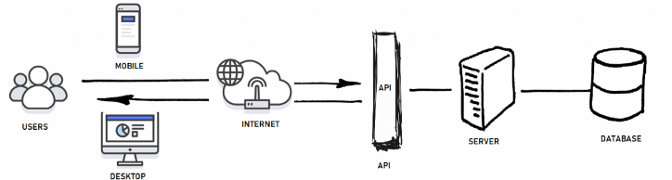
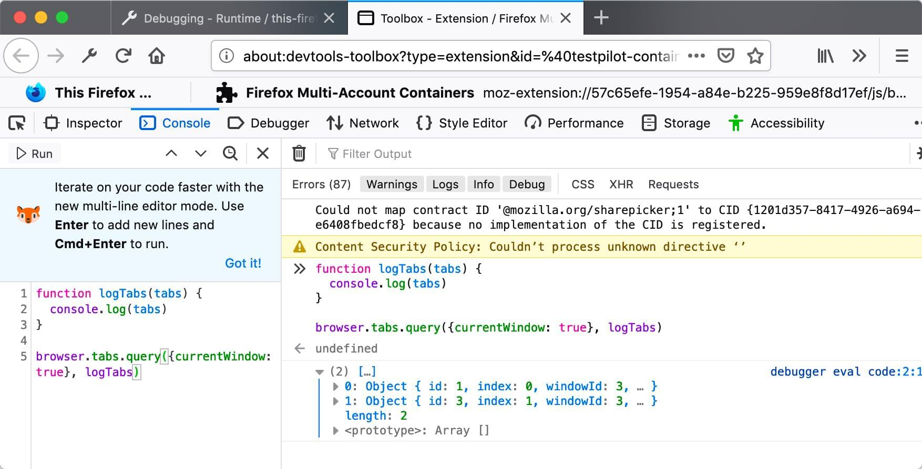
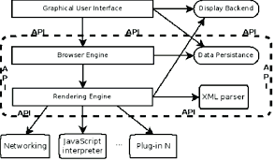
Definition:
Browser APIs are built-in APIs provided by web browsers.
Examples:
- DOM API
- Fetch API
- Storage API
- Geolocation API
Key Points:
- Available only in browsers
- Improve user experience
- Secure access
When Used:
- UI manipulation
- Data fetching
- Browser storage

🔹 Fetch API (Data Handling)
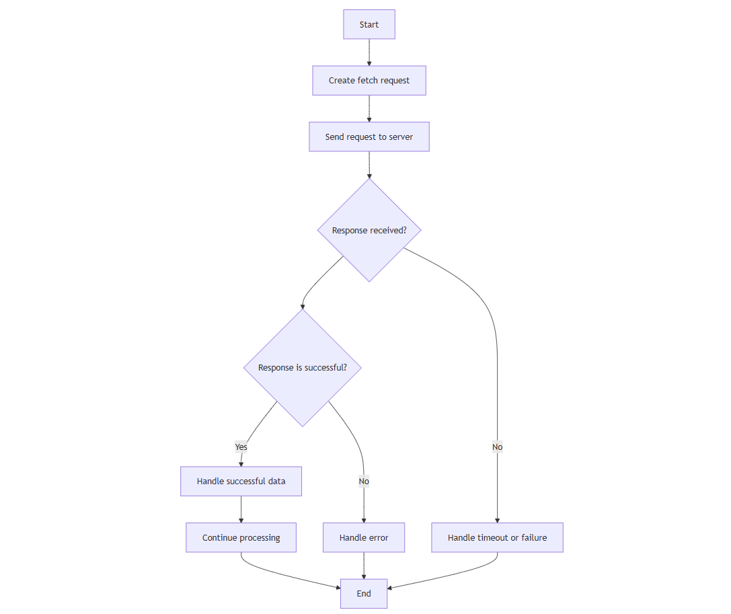
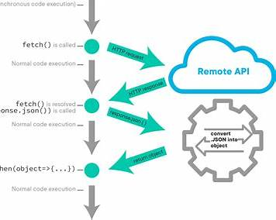
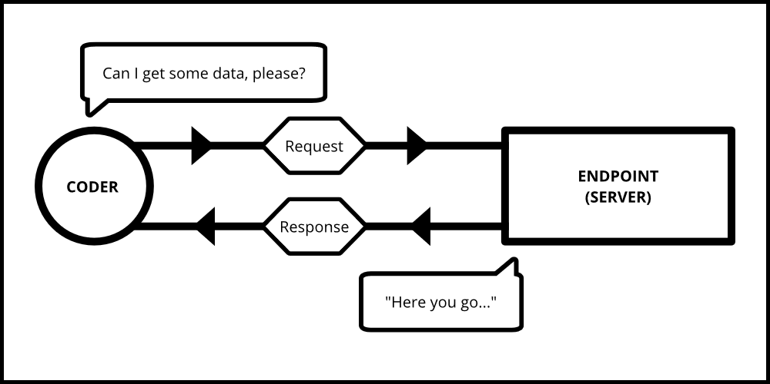
Definition:
Fetch API is used to make HTTP requests and receive responses.
Explanation:
Fetch returns a Promise that resolves with a response object.
Key Points:
- Uses promises
- Supports GET, POST, PUT, DELETE
- Works with async/await
Why Used:
- API calls
- Server communication

🔹 JSON (JavaScript Object Notation)
Definition:
JSON is a lightweight data format used to exchange data between client and server.
Key Points:
- JSON.parse() → JSON to Object
- JSON.stringify() → Object to JSON
Why Used:
- Standard data format
- Easy to read & write

🔹 LocalStorage & SessionStorage

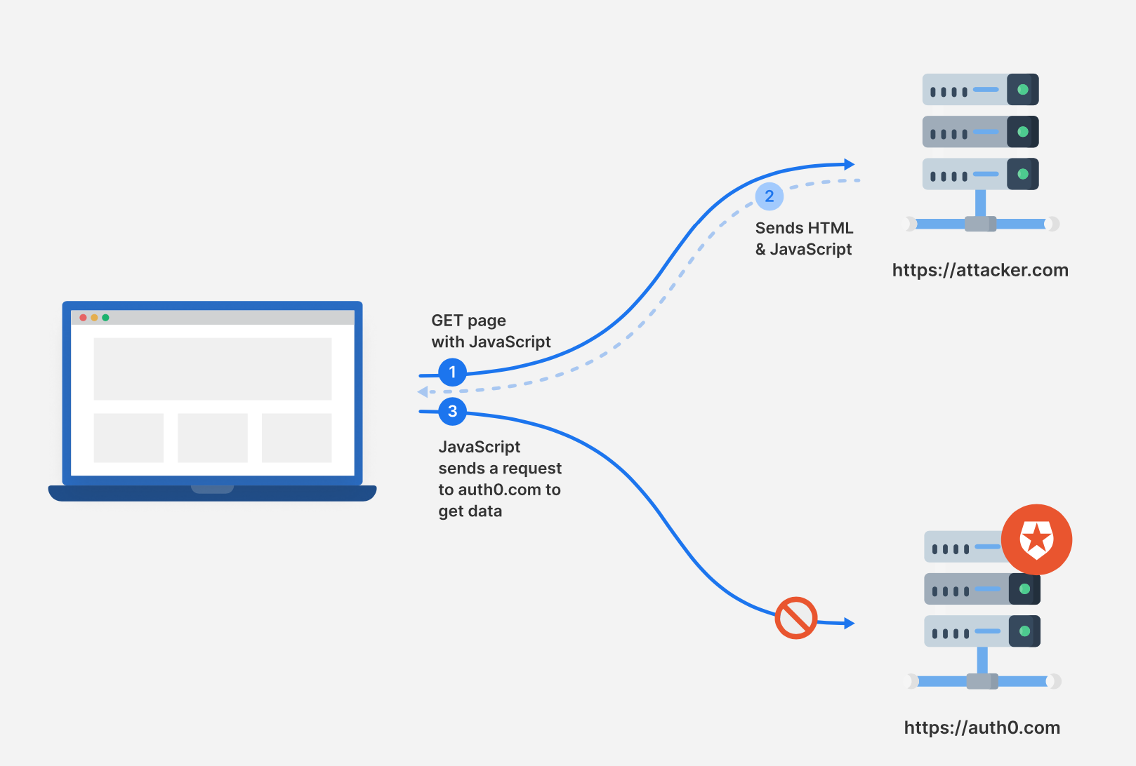
Definition:
Web Storage APIs allow storing data in the browser.
Feature | localStorage | sessionStorage
Persistence | Permanent | Until tab closes
Size | ~5MB | ~5MB
Use case | Preferences | Temporary data
Why Used:
- Save user data
- Reduce server calls

💻 2. Class Examples (Teacher Live Demos)

✅ Example 1: Fetch API

fetch("https://jsonplaceholder.typicode.com/users")
.then(res => res.json())
.then(data => console.log(data));

🧑‍🏫 Fetching data from server.

✅ Example 2: Fetch with async/await

async function getUsers() {
const res = await fetch("https://jsonplaceholder.typicode.com/users");
const data = await res.json();
console.log(data);
}
getUsers();

🧑‍🏫 Cleaner async syntax.

✅ Example 3: JSON parse & stringify

const user = { name: "Arun", age: 25 };
const json = JSON.stringify(user);
const obj = JSON.parse(json);

🧑‍🏫 Converting data formats.

✅ Example 4: localStorage

localStorage.setItem("theme", "dark");
console.log(localStorage.getItem("theme"));

🧑‍🏫 Persistent browser storage.

✅ Example 5: sessionStorage

sessionStorage.setItem("login", "true");

🧑‍🏫 Temporary session storage.

Day 32 is not there

Day 33:

Notes (Definitions & Explanations)

🔹 What is React?
Definition:
React is a JavaScript library used for building user interfaces, mainly for single-page applications (SPA).
Explanation:
React allows developers to create reusable UI pieces called components, making applications easier to manage.
Key Points:
- Developed by Facebook
- Component-based
- Declarative UI
Why Used:
- Faster UI updates
- Reusable components
- Large community support

🔹 Why React is Used?
Problems with Traditional JS:
- Manual DOM updates
- Hard to manage large apps
- Code repetition
React Solution:
- Automatic UI updates
- Component reusability
- Better performance

🔹 SPA vs Traditional Websites
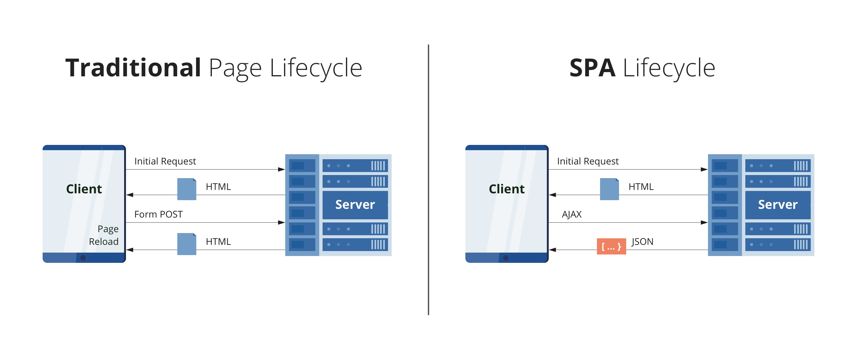
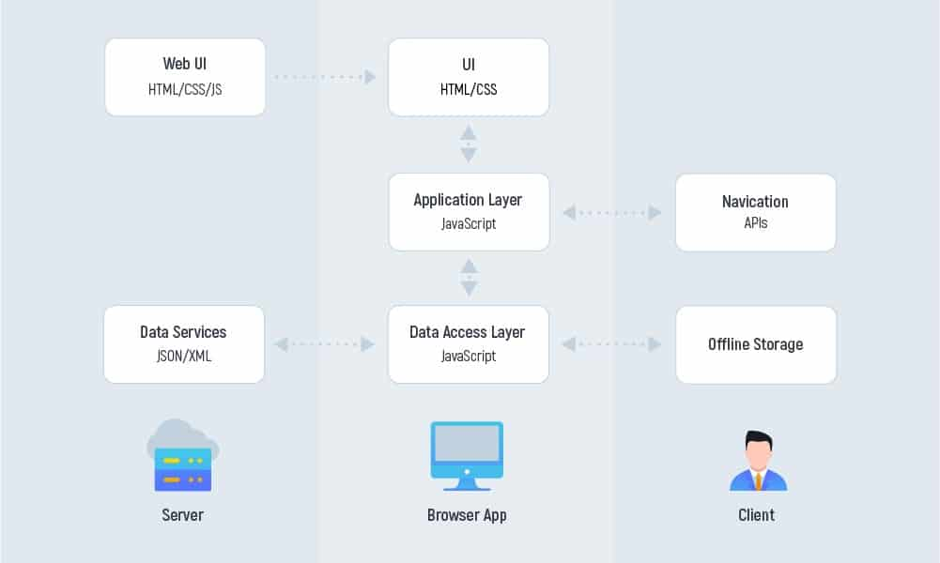
Feature | Traditional Website | SPA
Page Reload | Yes | No
Speed | Slower | Faster
UX | Normal | Smooth
Data Fetching | Page-based | API-based

🔹 React Features
Core Features:
- Component-based architecture
- Virtual DOM
- One-way data flow
- JSX syntax
Why Important:
- Clean code structure
- Easy maintenance

🔹 Virtual DOM (Concept)
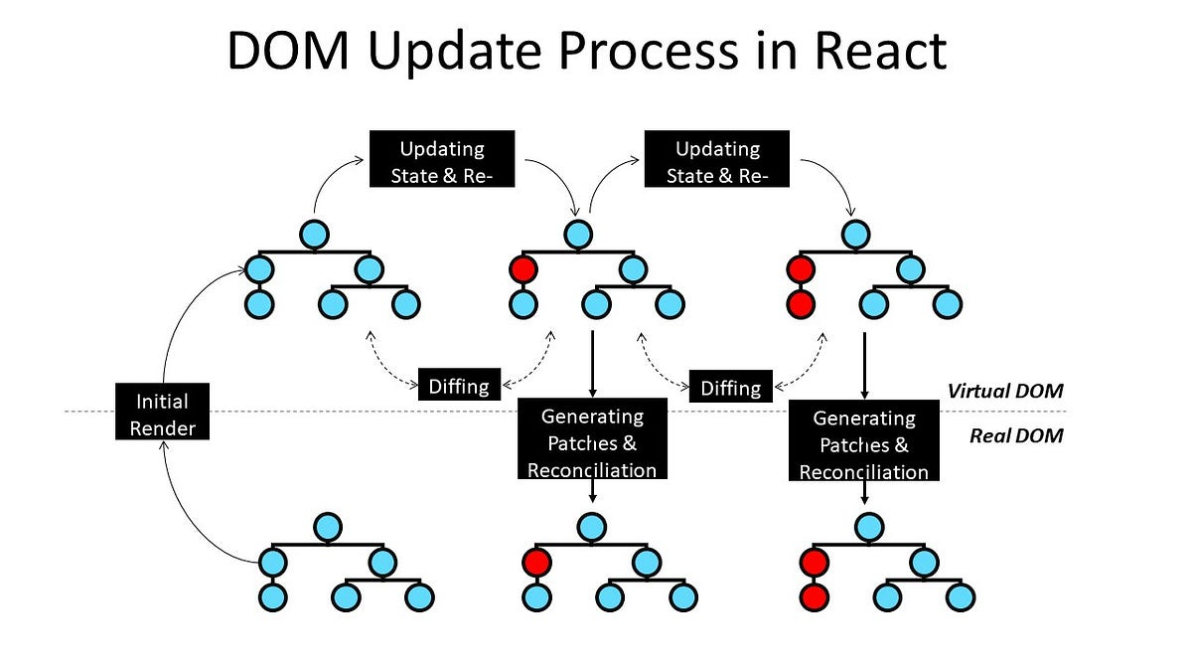

Definition:
Virtual DOM is a lightweight copy of the real DOM.
Explanation:
React updates only the changed parts instead of reloading the entire DOM.
Key Points:
- Improves performance
- Efficient updates

🔹 React vs Vanilla JavaScript (Overview)
Feature | Vanilla JS | React
DOM Handling | Manual | Automatic
Code Structure | Script-based | Component-based
Scalability | Low | High
Learning Curve | Low | Moderate

🔹 React Ecosystem (Intro)
Includes:
- React Router (Navigation)
- Redux (State Management)
- Vite / CRA (Setup tools)
- Tailwind / CSS frameworks

💻 2. Class Examples (Teacher Live Demos)

✅ Example 1: Simple HTML vs React Concept

<h1>Hello World</h1>

🧑‍🏫 Static UI example.

✅ Example 2: React Component (Conceptual)

function Hello() {
return <h1>Hello World</h1>;
}

🧑‍🏫 UI as a reusable component.

✅ Example 3: JSX Syntax

const name = "Arun";
<h2>Hello {name}</h2>

🧑‍🏫 JavaScript inside HTML-like syntax.

✅ Example 4: Component Reuse

<Header />
<Header />

🧑‍🏫 Same component reused multiple times.

✅ Example 5: One-Way Data Flow

<Profile name="Arun" />

🧑‍🏫 Data flows from parent to child.

Day 34

Notes (Definitions & Explanations)

1.1 What is a React Component?
Definition:
A component is a reusable piece of UI that returns JSX.
Explanation:
Instead of writing one large HTML page, React allows us to split UI into smaller parts like:
- Header
- Footer
- Card
- Button
Each part becomes a component.
Key Points:
- Components start with a capital letter
- Can be reused multiple times
- Makes code clean and maintainable
When/Why Used:
- To avoid repeating code
- To manage large applications easily

1.2 Functional Components
Definition:
A functional component is a JavaScript function that returns JSX.
Syntax:

function Welcome() {
return <h1>Welcome to React</h1>;
}

Key Points:
- Simple JavaScript functions
- Can use Hooks (useState, useEffect)
- Most commonly used component type today
When/Why Used:
- For all modern React development
- Cleaner and easier than class components

1.3 Props (Properties)
Definition:
Props are inputs passed from a parent component to a child component.
Explanation:
Props allow components to be dynamic instead of hardcoded.
Example:

function Greeting(props) {
return <h2>Hello {props.name}</h2>;
}

<Greeting name="Arun" />

Key Points:
- Props are read-only
- Passed like HTML attributes
- Help reuse components with different data
When/Why Used:
- To display dynamic data
- To communicate between components

1.4 Props vs State (Intro)
Props | State
Passed from parent | Managed inside component
Read-only | Can be changed
Used for configuration | Used for data changes
👉 Today’s focus: Props (State will be deep-dived later)

1.5 children Prop
Definition:
children is a special prop that represents content placed between component tags.
Example:

function Card(props) {
return <div className="card">{props.children}</div>;
}

<Card>
<h2>Title</h2>
<p>Description</p>
</Card>

Key Points:
- Enables component nesting
- Makes layout components reusable
- Very common in real projects
When/Why Used:
- Layouts (Card, Modal, Wrapper)
- Reusable UI containers

💻 2. Class Examples (Teacher Live Demos)

Example 1: Simple Functional Component

function Hello() {
return <h1>Hello World</h1>;
}

🧑‍🏫 Basic component returning JSX.

Example 2: Component with Props

function User(props) {
return <p>Name: {props.name}</p>;
}

🧑‍🏫 Data passed from parent to child.

Example 3: Multiple Props

function Product({ name, price }) {
return <p>{name} - ₹{price}</p>;
}

🧑‍🏫 Destructuring props for clean code.

Example 4: Using children

function Box({ children }) {
return <div className="box">{children}</div>;
}

🧑‍🏫 Reusable wrapper component.

Example 5: Parent → Child Communication

function App() {
return <Greeting name="Student" />;
}

🧑‍🏫 Props flow is one-way.
Day 35

Notes (Definitions & Explanations)

1.1 What is State in React?
Definition:
State is a built-in object that stores data which can change over time and affects what is rendered on the UI.
Explanation:
Unlike props, state is managed inside the component and updates dynamically when users interact with the app.
Key Points:
- State changes cause re-render
- Local to the component
- Managed using Hooks
When/Why Used:
- Counters
- Form inputs
- Toggle switches

1.2 useState Hook
Definition:
useState is a React Hook that lets functional components store and update state.
Syntax:

const [count, setCount] = useState(0);

Explanation:
- count → current state value
- setCount → function to update state
- 0 → initial value
Key Points:
- Never update state directly
- Use setter function only

1.3 Updating State Correctly
❌ Wrong Way

count = count + 1;

✅ Correct Way

setCount(count + 1);

✅ Using Previous State

setCount(prev => prev + 1);

Why Important:
Ensures React updates UI correctly and avoids bugs.

1.4 Event Handling in React
Definition:
Event handling allows React components to respond to user actions like clicks, typing, or hovering.
Example:

<button onClick={handleClick}>Click Me</button>

Key Points:
- Events use camelCase
- Pass function reference, not function call

1.5 Passing Arguments to Event Handlers

<button onClick={() => handleClick(5)}>Add 5</button>

Explanation:
Arrow functions allow passing arguments safely.

💻 2. Class Examples (Teacher Live Demos)

Example 1: Simple Counter

const [count, setCount] = useState(0);
<button onClick={() => setCount(count + 1)}>+</button>

🧑‍🏫 Demonstrates state update on click.

Example 2: Toggle Button

const [isOn, setIsOn] = useState(false);
<button onClick={() => setIsOn(!isOn)}>Toggle</button>

🧑‍🏫 Boolean state handling.

Example 3: Input Handling

const [name, setName] = useState("");
<input onChange={e => setName(e.target.value)} />

🧑‍🏫 Captures user input.

Example 4: Multiple States

const [age, setAge] = useState(18);

🧑‍🏫 Components can have multiple states.

Example 5: Button Disable

<button disabled={count === 0}>Submit</button>

🧑‍🏫 UI reacts to state changes.
Day 36

Notes (Definitions & Explanations)

1.1 What is Conditional Rendering?
Definition:
Conditional rendering means displaying different UI based on a condition.
Explanation:
React uses JavaScript conditions (if, else, ternary, logical AND) to decide what to render.
Key Points:
- Based on state or props
- Makes UI dynamic
- No special React syntax — pure JS
When/Why Used:
- Login / Logout UI
- Loading messages
- Show / hide components

1.2 Conditional Rendering Techniques

✅ Using if / else

if (isLoggedIn) {
return <Dashboard />;
}
return <Login />;

✅ Using Ternary Operator

{isLoggedIn ? <Dashboard /> : <Login />}

✅ Using Logical AND (&&)

{isAdmin && <AdminPanel />}

Key Points:
- Ternary is most common in JSX
- && is useful for simple conditions

1.3 Rendering Lists in React
Definition:
Rendering lists means displaying multiple elements from an array.
Explanation:
React uses JavaScript’s map() method to convert arrays into JSX elements.
Example:

const fruits = ["Apple", "Banana", "Orange"];

{fruits.map(fruit => (
<li>{fruit}</li>
))}

Key Points:
- Always use map()
- Each item becomes a JSX element
When/Why Used:
- Product lists
- User lists
- Blog posts

1.4 Keys in React
Definition:
A key is a unique identifier given to list items to help React track changes.
Example:

{fruits.map((fruit, index) => (
<li key={index}>{fruit}</li>
))}

Why Keys Matter:
- Helps React identify items
- Improves performance
- Prevents rendering bugs
Best Practice:
- Use unique IDs, not index (if available)

<li key={product.id}>{product.name}</li>

1.5 Common Mistakes
❌ Missing key
❌ Using index when list changes
❌ Rendering objects directly
❌ Complex logic inside JSX
✅ Keep JSX clean
✅ Use helper functions if needed

💻 2. Class Examples (Teacher Live Demos)

Example 1: Show / Hide Text

{show && <p>Hello React</p>}

🧑‍🏫 Simple conditional rendering.

Example 2: Login Toggle

{isLoggedIn ? <Home /> : <Login />}

🧑‍🏫 Real-world authentication UI.

Example 3: Render Number List

{numbers.map(n => <li key={n}>{n}</li>)}

🧑‍🏫 Mapping array to JSX.

Example 4: User List with Key

{users.map(user => (
<p key={user.id}>{user.name}</p>
))}

🧑‍🏫 Correct key usage.

Example 5: Empty List Message

{items.length === 0 && <p>No items found</p>}

🧑‍🏫 Conditional message rendering.

Day 37

Notes (Definitions & Explanations)

1.1 Forms in React
Definition:
Forms in React allow users to enter and submit data through input elements like textboxes, checkboxes, and dropdowns.
Explanation:
Unlike plain HTML, React manages form values using state, giving full control over user input.
Key Points:
- Uses onChange instead of onInput
- Form data stored in component state
When/Why Used:
- Login / Register pages
- Search bars
- Feedback forms

1.2 Controlled Components
Definition:
A controlled component is a form element whose value is controlled by React state.
Explanation:
The input value comes from state, and every change updates the state.
Basic Example:

const [name, setName] = useState("");

<input
type="text"
value={name}
onChange={(e) => setName(e.target.value)}
/>

Key Points:
- Single source of truth (state)
- Easier validation and debugging
- Recommended approach in React

1.3 onChange & value
Explanation:
- value → displays state value
- onChange → updates state when user types

<input value={email} onChange={e => setEmail(e.target.value)} />

Why Important:
Without onChange, input becomes read-only.

1.4 Handling Multiple Inputs
Example Using One State Object:

const [formData, setFormData] = useState({
username: "",
password: ""
});

function handleChange(e) {
setFormData({
...formData,
[e.target.name]: e.target.value
});
}

<input name="username" onChange={handleChange} />
<input name="password" onChange={handleChange} />

Key Points:
- Use name attribute
- Spread operator keeps old values

1.5 Form Submission & Basic Validation

function handleSubmit(e) {
e.preventDefault();

if (!email) {
alert("Email is required");
}
}

Key Points:
- Use preventDefault()
- Validate before submitting
- Ready for API integration

💻 2. Class Examples (Teacher Live Demos)

Example 1: Single Input Form

const [name, setName] = useState("");
<input value={name} onChange={e => setName(e.target.value)} />

🧑‍🏫 Controlled input example.

Example 2: Email Input

<input type="email" value={email} onChange={handleEmail} />

🧑‍🏫 Email handling with state.

Example 3: Multiple Inputs

<input name="age" onChange={handleChange} />

🧑‍🏫 One handler for many inputs.

Example 4: Submit Button

<form onSubmit={handleSubmit}>

🧑‍🏫 Prevents page reload.

Example 5: Display Live Input

<p>{name}</p>

🧑‍🏫 Shows real-time data binding.

Day 38

Notes (Definitions & Explanations)

1.1 What is useEffect?
Definition:
useEffect is a React Hook that lets you run side effects in functional components.
Explanation:
Before hooks, side effects were handled using lifecycle methods like componentDidMount.
useEffect combines all of that behavior into one simple API.
Key Points:
- Runs after render
- Re-runs when dependencies change
- Keeps rendering logic clean
When/Why Used:
- API calls
- DOM updates
- Timers & intervals

1.2 Side Effects in React
Definition:
A side effect is any operation that affects something outside the component’s render output.
Examples:
- Fetching data from server
- Updating document.title
- Setting timers
Why Important:
React rendering must stay pure. Side effects must live in useEffect.

1.3 Basic useEffect Syntax

useEffect(() => {
console.log("Effect ran");
}, []);

Explanation:
- First argument → effect function
- Second argument → dependency array

1.4 Dependency Array Explained

🔹 No Dependency Array

useEffect(() => {
console.log("Runs on every render");
});

📌 Runs after every render

🔹 Empty Dependency Array []

useEffect(() => {
console.log("Runs once");
}, []);

📌 Runs only once (on mount)

🔹 With Dependencies

useEffect(() => {
console.log("Count changed");
}, [count]);

📌 Runs only when count changes

1.5 Common Mistakes
❌ Missing dependency array
❌ Updating state without dependency
❌ Infinite loops
❌ Placing side effects inside JSX
✅ Always ask: When should this effect run?

💻 2. Class Examples (Teacher Live Demos)

Example 1: Run Once on Page Load

useEffect(() => {
console.log("Component mounted");
}, []);

🧑‍🏫 Mimics componentDidMount.

Example 2: Run on Every Render

useEffect(() => {
console.log("Rendered");
});

🧑‍🏫 Demonstrates missing dependency array.

Example 3: State-Based Effect

useEffect(() => {
console.log("Value changed");
}, [value]);

🧑‍🏫 Controlled execution.

Example 4: Update Document Title

useEffect(() => {
document.title = `Count ${count}`;
}, [count]);

🧑‍🏫 Real-world side effect.

Example 5: Console Debug Effect

useEffect(() => {
console.log("Debugging effect");
});

🧑‍🏫 Useful for learning render cycles.

Day 39

Notes (Definitions & Explanations)

1. What is React Router DOM?
Definition:
React Router DOM is a library used to handle client-side routing in React applications.
Explanation:
Instead of loading new HTML pages, React Router changes components based on the URL.
Key Points:
- Used in Single Page Applications (SPA)
- No browser reload
- URL changes → component changes
Why it’s used:
To build multi-page React apps like dashboards, admin panels, CMS, e-commerce.

2. Installing React Router DOM (Latest)

npm install react-router-dom

Important Note (v6+):
- Switch ❌ (removed)
- Routes ✅ (used now)
- component ❌
- element ✅

3. BrowserRouter, Routes & Route

BrowserRouter
Wraps the entire application and enables routing.

Routes
A container for all routes.

Route
Maps a URL path to a component.

import { BrowserRouter, Routes, Route } from "react-router-dom";
import Home from "./Home";
import About from "./About";

function App() {
return (
<BrowserRouter>
<Routes>
<Route path="/" element={<Home />} />
<Route path="/about" element={<About />} />
</Routes>
</BrowserRouter>
);
}

Key Points:
- Each Route loads one component
- Clean and readable routing structure

4. Creating Multiple Pages
Each page is just a separate React component.

function Home() {
return <h2>Home Page</h2>;
}

function About() {
return <h2>About Page</h2>;
}

Why used:
Better code structure and reusability.

5. Link vs NavLink

Link
Used for navigation without page reload.

import { Link } from "react-router-dom";

<Link to="/about">About</Link>

NavLink
Same as Link but supports active styling.

import { NavLink } from "react-router-dom";

<NavLink
to="/"
className={({ isActive }) => (isActive ? "active" : "")}
>
Home
</NavLink>

Difference:
- Link → simple navigation
- NavLink → navigation + active state

6. Dynamic Routing – useParams
Definition:
useParams is used to read dynamic values from URL.

<Route path="/user/:id" element={<User />} />

import { useParams } from "react-router-dom";

function User() {
const { id } = useParams();
return <h3>User ID: {id}</h3>;
}

Where used:
User profile, product details, order pages.

7. Programmatic Navigation – useNavigate
Definition:
Used to navigate through code, not clicks.

import { useNavigate } from "react-router-dom";

function Login() {
const navigate = useNavigate();

const handleLogin = () => {
navigate("/dashboard");
};

return <button onClick={handleLogin}>Login</button>;
}

Where used:
Login, logout, role-based redirection.

8. 404 Page (Not Found Route)

<Route path="*" element={<NotFound />} />

function NotFound() {
return <h2>404 – Page Not Found</h2>;
}

Why important:
Handles invalid URLs professionally.

💻 2. Class Examples (Teacher Live Demos)

Example 1: Basic Routing

<Route path="/" element={<Home />} />
<Route path="/about" element={<About />} />

➡ Multi-page SPA navigation.

Example 2: Navbar Using Link

<Link to="/">Home</Link>
<Link to="/about">About</Link>

➡ No page reload.

Example 3: Dynamic Route

<Route path="/product/:pid" element={<Product />} />

➡ Used in e-commerce apps.

Example 4: Redirect After Login

navigate("/dashboard");

➡ Common interview example.

Day 40

Notes (Definitions & Explanations)

1. What is Tailwind CSS?
Definition:
Tailwind CSS is a utility-first CSS framework.
Explanation:
Instead of writing custom CSS classes, we apply small utility classes directly in JSX.
Key Points:
- No separate CSS for most cases
- Faster UI development
- Highly customizable
Why it’s used:
Saves time, avoids CSS conflicts, perfect for React projects.

2. Tailwind CSS vs Traditional CSS
Traditional CSS | Tailwind CSS
Write custom class names | Use utility classes
Separate CSS file | Styles inside JSX
Slower for UI changes | Very fast iteration
CSS conflicts possible | No naming conflicts

3. Installing Tailwind CSS in React

npm install -D tailwindcss postcss autoprefixer
npx tailwindcss init -p

Configure tailwind.config.js:

content: ["./src/**/*.{js,jsx,ts,tsx}"],

Add to index.css:

@tailwind base;
@tailwind components;
@tailwind utilities;

✅ Tailwind is now ready.

4. Utility Classes Basics

Spacing

<p className="p-4 m-2">Hello</p>

Colors

<p className="text-blue-600 bg-gray-100">Text</p>

Font & Size

<h1 className="text-2xl font-bold">Title</h1>

Why utility classes?
One class → one job → predictable styling.

5. Layout – Flexbox

<div className="flex justify-between items-center">
<p>Left</p>
<p>Right</p>
</div>

Common Classes:
- flex
- justify-center
- items-center
- gap-4

6. Cards & Buttons (Practical UI)

Button

<button className="bg-blue-500 text-white px-4 py-2 rounded hover:bg-blue-600">
Click Me
</button>

Card

<div className="border p-4 rounded shadow-md w-64">
<h3 className="font-bold text-lg">Card Title</h3>
<p className="text-gray-600">Description</p>
</div>

Why important:
Buttons & cards appear in every real project.

7. Forms Styling

<input
type="text"
placeholder="Enter name"
className="border p-2 rounded w-full"
/>

<form className="space-y-4">
<input className="border p-2 w-full" />
<button className="bg-green-500 text-white p-2 rounded">
Submit
</button>
</form>

8. Responsive Design (Basics)
Tailwind uses mobile-first breakpoints.

<div className="text-sm md:text-lg lg:text-xl">
Responsive Text
</div>

Prefix | Screen
sm: | Mobile
md: | Tablet
lg: | Laptop
xl: | Desktop

9. Best Practices
- Keep JSX readable
- Group related classes
- Avoid over-styling
- Use Tailwind for layout, CSS only if needed

💻 2. Class Examples (Teacher Live Demos)

Example 1: Styled Header

<h1 className="text-3xl font-bold text-center text-blue-600">
Welcome
</h1>

➡ Quick typography styling.

Example 2: Button with Hover

<button className="bg-red-500 hover:bg-red-600 text-white px-4 py-2 rounded">
Delete
</button>

➡ Interactive UI.

Example 3: Flex Layout

<div className="flex gap-4">
<div className="bg-gray-200 p-4">Box 1</div>
<div className="bg-gray-300 p-4">Box 2</div>
</div>

➡ Responsive layout.

Example 4: Simple Login Card

<div className="max-w-sm mx-auto p-6 border rounded">
<input className="border p-2 w-full mb-3" />
<button className="bg-blue-500 text-white w-full p-2 rounded">
Login
</button>
</div>

➡ Real-world UI.

Day 41

Notes (Definitions & Explanations)

1. What is State Management?
Definition:
State management means handling and controlling application data efficiently.
Example:
User login status, cart items, theme, user profile.
Problem without Redux:
- Props drilling
- Hard to track data changes
- Messy code in large apps

2. Why Redux?
Definition:
Redux is a predictable state container for JavaScript applications.
Key Points:
- Single source of truth
- Centralized state
- Easier debugging
- Scales well for large apps
Why used:
When multiple components need same data.

3. Core Redux Concepts (Very Important)

🔵 A. Store
Definition:
The store holds the entire application state.
Key Points:
- Only ONE store per app
- Stores data centrally
- Components read data from store
Think of store as:
🧠 Brain of the application

🟢 B. Actions
Definition:
Actions are plain JavaScript objects that describe what happened.

{
type: "INCREMENT"
}

Key Points:
- Must have a type
- Used to trigger state changes
- Does NOT change state directly
Think of action as:
📢 Message / command

🟠 C. Reducers
Definition:
Reducers are pure functions that decide how state changes.

const reducer = (state, action) => {
switch (action.type) {
case "INCREMENT":
return state + 1;
default:
return state;
}
};

Rules of Reducer:
- Must be pure
- No direct mutation
- Always return new state
Think of reducer as:
⚙️ Decision maker

4. Redux Data Flow (Interview Favorite)
- Component dispatches Action
- Action goes to Reducer
- Reducer updates State
- Store stores updated state
- UI updates automatically
➡ One-way data flow

5. Simple Redux Example (Conceptual)

Action

const increment = {
type: "INCREMENT"
};

Reducer

const counterReducer = (state = 0, action) => {
switch (action.type) {
case "INCREMENT":
return state + 1;
default:
return state;
}
};

Store

import { createStore } from "redux";

const store = createStore(counterReducer);

➡ State is now managed globally.

6. Redux vs useState / Props
Feature | useState | Redux
Scope | Local | Global
Props drilling | Yes | No
Best for | Small apps | Large apps
Debugging | Limited | Excellent

7. When to Use Redux
✅ Use Redux when:
- Large application
- Shared state across many components
- Complex business logic
❌ Avoid Redux when:
- Small apps
- Simple state needs

💻 2. Class Examples (Teacher Live Demos)

Example 1: Without Redux (Problem)

<App>
<Header user={user} />
<Dashboard user={user} />
</App>

➡ Props drilling issue.

Example 2: Redux Action

{ type: "LOGIN" }

➡ Describes what happened.

Example 3: Redux Reducer

case "LOGIN":
return { ...state, isLoggedIn: true };

➡ Controlled state update.

Example 4: Redux Store

const store = createStore(rootReducer);

➡ Centralized state.

Day 42

Notes (Definitions & Explanations)

🔹 What is SQL?
Definition:
SQL (Structured Query Language) is a standard language used to communicate with databases.
Explanation:
SQL allows us to create tables, insert data, retrieve data, update records, and delete records.
Key Points:
- Not a programming language
- Works with databases
- Case-insensitive (mostly)
Why Used:
- Data storage
- Data retrieval
- Data manipulation

🔹 What is a Database?
Definition:
A database is an organized collection of data stored electronically.
Explanation:
Data is stored in tables made of rows and columns.
Example:
- Table → Excel sheet
- Row → Record
- Column → Field
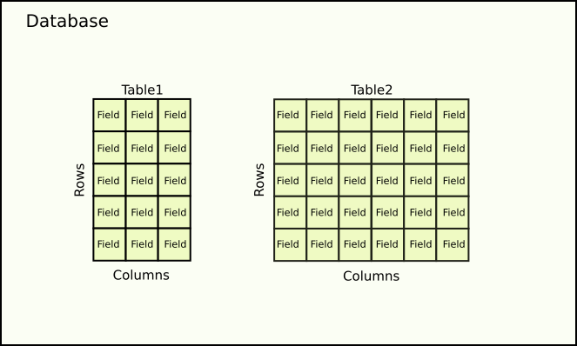
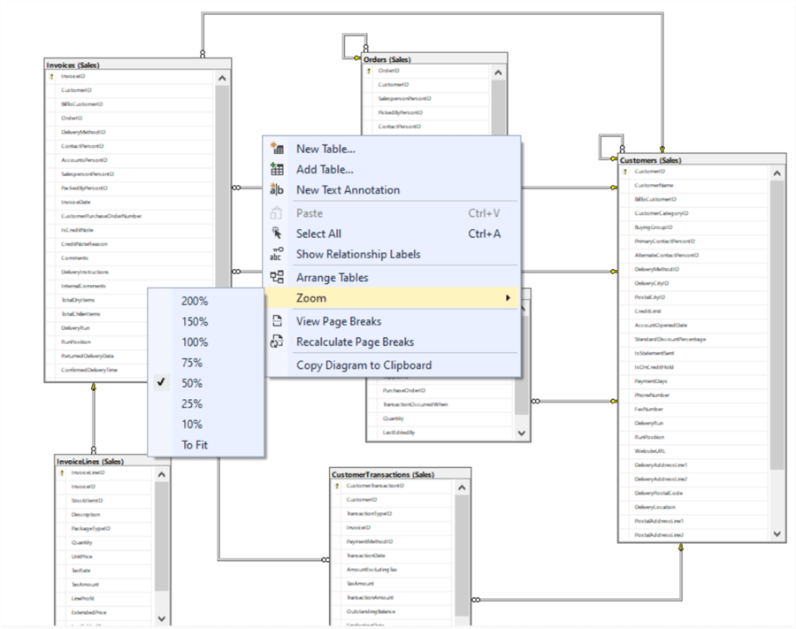

🔹 SQL vs DBMS
SQL | DBMS
Language | Software
Used to query data | Used to store data
Example: SQL | Example: MySQL
Explanation:
- SQL is the language
- DBMS is the tool that understands SQL

🔹 Installing Database Software (MySQL – Overview)
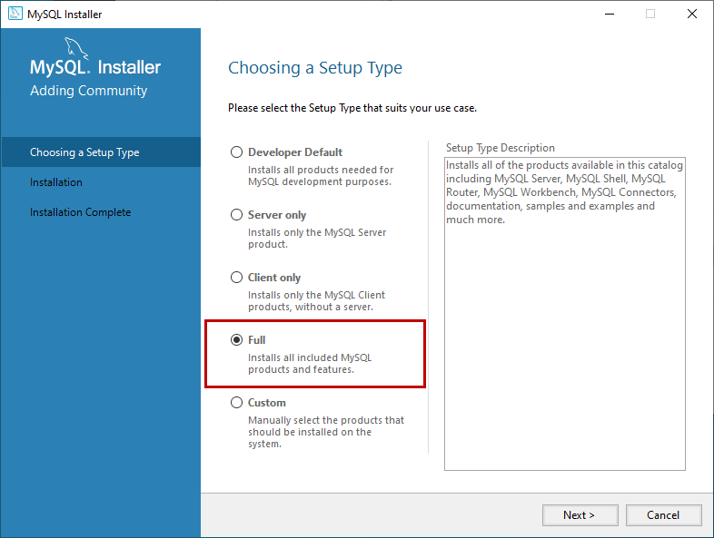
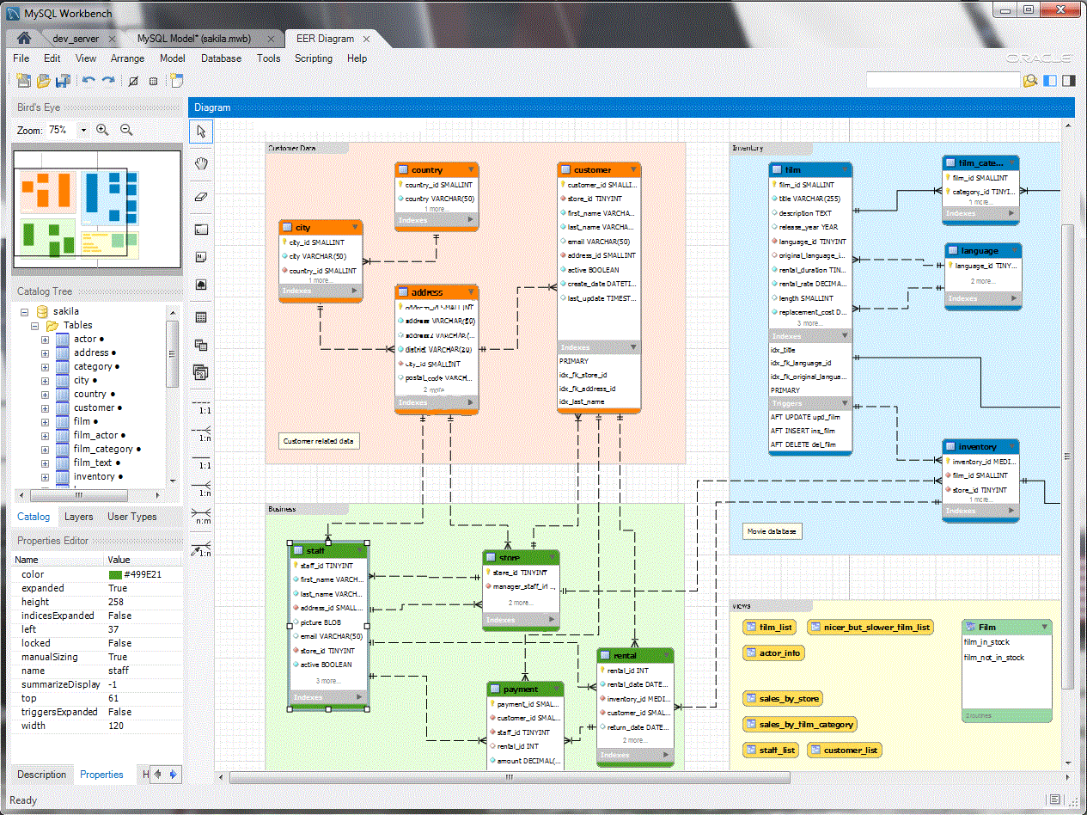
Steps (High-level):
- Download MySQL Installer
- Install MySQL Server
- Install MySQL Workbench
- Set root password
- Connect to local server
Why MySQL?
- Free & popular
- Widely used in industry
- Beginner-friendly
(Installation demo can be shown live)

🔹 SQL Basic Syntax Rules
Important Rules:
- SQL keywords are case-insensitive
- Statements end with ;
- Strings use single quotes ' '
- SQL ignores extra spaces
Example:

SELECT * FROM students;

🔹 SQL Command Types (Intro)
Type | Full Form | Use
DDL | Data Definition Language | Create/modify tables
DML | Data Manipulation Language | Insert/update/delete data
DQL | Data Query Language | Fetch data

🔹 Basic SQL Commands

✅ SELECT (Read Data)

SELECT * FROM students;

✅ INSERT (Add Data)

INSERT INTO students VALUES (1, 'Arun', 22);

✅ UPDATE (Modify Data)

UPDATE students SET age = 23 WHERE id = 1;

✅ DELETE (Remove Data)

DELETE FROM students WHERE id = 1;

💻 2. Class Examples (Teacher Live Demos)

✅ Example 1: Create Database

CREATE DATABASE college;

🧑‍🏫 Creates a new database.

✅ Example 2: Create Table

CREATE TABLE students (
id INT,
name VARCHAR(50),
age INT
);

🧑‍🏫 Defines table structure.

✅ Example 3: Insert Record

INSERT INTO students VALUES (1, 'Ravi', 21);

🧑‍🏫 Adds data to table.

✅ Example 4: Select Records

SELECT name, age FROM students;

🧑‍🏫 Fetches specific columns.

✅ Example 5: Delete Record

DELETE FROM students WHERE id = 1;

🧑‍🏫 Removes data safely using condition.

Day 43

Notes (Definitions & Explanations)

1. What is Data?
Definition:
Data is raw facts and information.
Examples:
- Student name
- Employee salary
- Product price
Key Point:
Data becomes useful when it is organized.

2. What is a Database?
Definition:
A database is an organized collection of data stored electronically.
Explanation:
Instead of storing data in files, databases store data in tables.
Term | Meaning
Table | Collection of rows & columns
Row | One record
Column | One field
Why used:
Fast searching, updating, and managing large data.

3. What is DBMS?
Definition:
DBMS (Database Management System) is software that manages databases.
Examples:
- MySQL
- Oracle
- SQL Server
Responsibilities of DBMS:
- Data security
- Data consistency
- Multi-user access
- Backup & recovery

4. Why We Need Databases (File System vs Database)
File System | Database
Data duplication | No redundancy
No security | Secure access
Hard to search | Fast queries
No relationships | Relational data

5. What is SQL?
Definition:
SQL (Structured Query Language) is used to create, read, update, and delete data.
Explanation:
SQL is the communication language between user and database.
Key Points:
- Works with tables
- Standard language
- Easy to learn

6. SQL vs DBMS (Interview Important)
SQL | DBMS
Language | Software
Used to write queries | Stores & manages data
Same everywhere | Different systems
Interview Line:
👉 SQL is the language, DBMS is the system.

7. Real-World Database Examples
Application | Database Usage
Banking | Accounts, transactions
E-commerce | Products, orders
School | Students, marks
Hospital | Patients, reports

8. SQL Workflow (Big Picture)
- Create database
- Create tables
- Insert data
- Retrieve data
- Update / Delete data
👉 This is how real companies use SQL.

💻 2. Class Examples (Teacher Live Demos)

Example 1: Database Concept

CREATE DATABASE school_db;

➡ Creates a container for data.

Example 2: Use Database

USE school_db;

➡ Selects database.

Example 3: View Databases

SHOW DATABASES;

➡ Lists available databases.

Day 44

Notes (Definitions & Explanations)

1. What is a Table?
Definition:
A table is a structure that stores data in rows and columns.
Key Points:
- Each row = one record
- Each column = one field
- Structure defined before data insertion

2. SQL Data Types (Commonly Used)
Data Type | Usage
INT | Numbers
VARCHAR(n) | Text
DECIMAL(p,s) | Salary, price
DATE | Dates
BOOLEAN | True/False
👉 Choosing correct data type is critical.

3. CREATE TABLE Syntax

CREATE TABLE employees (
emp_id INT PRIMARY KEY AUTO_INCREMENT,
emp_name VARCHAR(50) NOT NULL,
dept_id INT,
salary DECIMAL(10,2),
email VARCHAR(100),
hire_date DATE
);

Explanation:
- Column name + data type
- Constraints added per column

4. Constraints (Very Important)
Definition:
Constraints are rules applied on table columns to maintain data integrity.

5. NOT NULL Constraint
Prevents empty values.

emp_name VARCHAR(50) NOT NULL

6. UNIQUE Constraint
Prevents duplicate values.

email VARCHAR(100) UNIQUE

7. PRIMARY KEY Constraint
- Uniquely identifies each row
- Cannot be NULL
- Only one per table

emp_id INT PRIMARY KEY AUTO_INCREMENT

8. DEFAULT Constraint
Assigns default value if none is provided.

status VARCHAR(20) DEFAULT 'active'

9. CHECK Constraint
Validates a condition.

salary DECIMAL(10,2) CHECK (salary > 0)

10. FOREIGN KEY Constraint
Creates relationship between tables.

FOREIGN KEY (dept_id) REFERENCES departments(dept_id)

Why used:
Maintains referential integrity.

11. Table-Level Constraints

CREATE TABLE payroll (
payroll_id INT AUTO_INCREMENT,
emp_id INT,
salary DECIMAL(10,2),
PRIMARY KEY (payroll_id),
FOREIGN KEY (emp_id) REFERENCES employees(emp_id)
);

12. PRIMARY KEY vs FOREIGN KEY
PRIMARY KEY | FOREIGN KEY
Unique | Repeated allowed
Identifies record | Links tables
One per table | Many per table

💻 2. Class Examples (Teacher Live Demos)

Example 1: Create Employees Table

CREATE TABLE employees (
emp_id INT PRIMARY KEY AUTO_INCREMENT,
emp_name VARCHAR(50) NOT NULL,
salary DECIMAL(10,2) CHECK (salary > 0)
);

➡ Safe and validated table.

Example 2: Create Departments Table

CREATE TABLE departments (
dept_id INT PRIMARY KEY,
dept_name VARCHAR(50) UNIQUE NOT NULL
);

➡ Prevents duplicate departments.

Example 3: Foreign Key Relationship

ALTER TABLE employees
ADD FOREIGN KEY (dept_id) REFERENCES departments(dept_id);

➡ Connects tables.

Day 45

Notes (Definitions & Explanations)

🔹 PART 1: ALTER TABLE (Structure Changes)

1. What is ALTER TABLE?
Definition:
ALTER TABLE is used to change the structure of an existing table.
Used for:
- Adding columns
- Modifying data types
- Renaming columns
- Dropping columns

2. ADD a New Column

ALTER TABLE employees
ADD status VARCHAR(20);

➡ Adds a new column to existing table.

3. ADD Column with DEFAULT

ALTER TABLE employees
ADD status VARCHAR(20) DEFAULT 'active';

➡ Automatically sets value if not provided.

4. MODIFY a Column
Used to change data type or size.

ALTER TABLE employees
MODIFY emp_name VARCHAR(100);

➡ Increases name length.

5. RENAME a Column

ALTER TABLE employees
RENAME COLUMN emp_name TO employee_name;

➡ Changes column name.

6. DROP a Column

ALTER TABLE employees
DROP COLUMN status;

⚠️ Data in that column will be lost.

7. ALTER Constraints (Intro)
Add UNIQUE constraint:

ALTER TABLE employees
ADD CONSTRAINT uq_email UNIQUE (email);

Drop constraint (name required):

ALTER TABLE employees
DROP INDEX uq_email;

🔹 PART 2: DML (Data Manipulation Language)

8. What is DML?
Definition:
DML commands are used to manipulate data inside tables.
Main Commands:
- INSERT
- UPDATE
- DELETE

9. INSERT Data

Insert Full Row

INSERT INTO employees
VALUES (1, 'Arun', 1, 45000, 'arun@company.com', '2022-01-10');

Insert Selected Columns (Recommended)

INSERT INTO employees (emp_name, dept_id, salary)
VALUES ('Priya', 2, 50000);

➡ Safer and professional.

10. INSERT Multiple Rows

INSERT INTO employees (emp_name, dept_id, salary) VALUES
('Rahul', 1, 38000),
('Sneha', 3, 60000),
('Karthik', 2, 47000);

11. UPDATE Data

UPDATE employees
SET salary = 55000
WHERE emp_id = 2;

⚠️ Always use WHERE to avoid updating all rows.

12. UPDATE Multiple Columns

UPDATE employees
SET salary = 60000, dept_id = 3
WHERE emp_name = 'Sneha';

13. DELETE Data

DELETE FROM employees
WHERE status = 'inactive';

➡ Deletes selected rows.

14. DELETE vs TRUNCATE
DELETE | TRUNCATE
Deletes specific rows | Deletes all rows
WHERE allowed | WHERE not allowed
Slower | Faster
Can rollback (txn) | Cannot rollback

15. Safe SQL Practices (Very Important)
✅ Always:
- Run SELECT before UPDATE / DELETE
- Use WHERE clause
- Backup data
❌ Avoid:
- Updating without condition
- Dropping columns carelessly

💻 2. Class Examples (Teacher Live Demos)

Example 1: Add Column

ALTER TABLE employees ADD joining_year INT;

➡ Schema evolution.

Example 2: Insert Employee

INSERT INTO employees (emp_name, salary)
VALUES ('Neha', 42000);

➡ Add new data.

Example 3: Salary Hike

UPDATE employees
SET salary = salary + 5000
WHERE dept_id = 1;

➡ Bulk update.

Example 4: Delete Record

DELETE FROM employees WHERE emp_id = 10;

➡ Remove specific record.

Day 46

Notes (Definitions & Explanations)

🔹 PART 1: FETCHING DATA

1. SELECT Statement
Definition:
SELECT is used to retrieve data from a table.

SELECT * FROM employees;

Key Points:
- * selects all columns
- Always specify columns in real projects

2. Selecting Specific Columns

SELECT emp_name, salary
FROM employees;

➡ Faster and cleaner.

3. WHERE Clause (Filtering Data)
Definition:
WHERE filters rows based on conditions.

SELECT emp_name, salary
FROM employees
WHERE salary > 40000;

4. Comparison Operators
Operator | Meaning
= | Equal
!= / <> | Not equal
>, < | Greater / Less
BETWEEN | Range
IN | Multiple values
LIKE | Pattern

WHERE salary BETWEEN 30000 AND 60000;

5. Logical Operators
Operator | Meaning
AND | All conditions
OR | Any condition
NOT | Negation

WHERE dept_id = 2 AND salary > 50000;

6. DISTINCT Keyword
Definition:
Removes duplicate values.

SELECT DISTINCT dept_id FROM employees;

🔹 PART 2: SORTING DATA

7. ORDER BY
Definition:
Sorts result set.

SELECT emp_name, salary
FROM employees
ORDER BY salary DESC;

Keyword | Meaning
ASC | Ascending
DESC | Descending

🔹 PART 3: AGGREGATION

8. Aggregate Functions
Function | Purpose
COUNT() | Number of rows
SUM() | Total
AVG() | Average
MIN() | Minimum
MAX() | Maximum

SELECT AVG(salary) FROM employees;

9. GROUP BY
Definition:
Groups rows to apply aggregate functions.

SELECT dept_id, AVG(salary)
FROM employees
GROUP BY dept_id;

10. HAVING Clause
Definition:
Filters groups (used after GROUP BY).

SELECT dept_id, AVG(salary)
FROM employees
GROUP BY dept_id
HAVING AVG(salary) > 45000;

11. WHERE vs HAVING (Interview Table)
WHERE | HAVING
Filters rows | Filters groups
Before GROUP BY | After GROUP BY
Cannot use aggregate | Uses aggregate

12. Query Execution Order (Very Important)

FROM
WHERE
GROUP BY
HAVING
SELECT
ORDER BY

💻 2. Class Examples (Teacher Live Demos)

Example 1: Fetch Active Employees

SELECT emp_name
FROM employees
WHERE status = 'active';

➡ Basic filtering.

Example 2: Highest Salary

SELECT emp_name, salary
FROM employees
ORDER BY salary DESC
LIMIT 1;

➡ Sorting + limit.

Example 3: Department-wise Count

SELECT dept_id, COUNT(*)
FROM employees
GROUP BY dept_id;

➡ Aggregation.

Example 4: Departments with Avg Salary > 50k

SELECT dept_id, AVG(salary)
FROM employees
GROUP BY dept_id
HAVING AVG(salary) > 50000;

➡ HAVING usage.

Day 47

Notes (Definitions & Explanations)

🔹 PART 1: SQL JOINS

1. Why We Need Multiple Tables
Problems with single table:
- Data duplication
- Update anomalies
- Difficult maintenance
Solution:
👉 Split data into related tables + use JOINS

2. What is a JOIN?
Definition:
A JOIN is used to combine rows from two or more tables based on a related column.
Example Tables:
- employees(emp_id, emp_name, dept_id)
- departments(dept_id, dept_name)

3. INNER JOIN
Definition:
Returns only matching records from both tables.

SELECT e.emp_name, d.dept_name
FROM employees e
INNER JOIN departments d
ON e.dept_id = d.dept_id;

Use Case:
Employee with department name.

4. LEFT JOIN
Definition:
Returns all records from left table and matching from right table.

SELECT e.emp_name, d.dept_name
FROM employees e
LEFT JOIN departments d
ON e.dept_id = d.dept_id;

Use Case:
Employees without department also included.

5. RIGHT JOIN
Definition:
Returns all records from right table and matching from left table.

SELECT e.emp_name, d.dept_name
FROM employees e
RIGHT JOIN departments d
ON e.dept_id = d.dept_id;

Use Case:
Departments without employees.

6. FULL JOIN (Conceptual)
Definition:
Returns all records from both tables.
⚠️ MySQL does not support FULL JOIN directly.

-- Concept
LEFT JOIN
UNION
RIGHT JOIN

7. JOIN vs Subquery (Interview Table)
JOIN | Subquery
Combines tables | Query inside query
Faster for large data | Easier to read
Preferred in reports | Used in conditions
Interview Line:
👉 JOINS are more performant, subqueries are more readable.

🔹 PART 2: DATABASE NORMALIZATION

8. What is Normalization?
Definition:
Normalization is the process of organizing data to reduce redundancy.
Simple Meaning:
👉 Don’t repeat the same data again and again.

9. Why Normalization is Important
Without normalization:
- Duplicate data
- Update problems
- Inconsistent values
With normalization:
- Clean structure
- Easy updates
- Reliable data

10. First Normal Form (1NF)
Rule:
- Atomic values
- No multi-valued columns
❌ Before:
emp_id | skills
1 | Java, SQL
✅ After:
emp_id | skill
1 | Java
1 | SQL

11. Second Normal Form (2NF)
Rule:
- Must be in 1NF
- No partial dependency
❌ Problem:
(emp_id, course_id) → course_name
✅ Solution:
- Students
- Courses
- Enrollments

12. Third Normal Form (3NF)
Rule:
- Must be in 2NF
- No transitive dependency
❌ Problem:
emp_id → dept_id → dept_name
✅ Solution:
- Employees(emp_id, dept_id)
- Departments(dept_id, dept_name)

13. Normalized Structure with JOINS

Employees(emp_id, emp_name, dept_id)
Departments(dept_id, dept_name)

SELECT emp_name, dept_name
FROM employees
JOIN departments
ON employees.dept_id = departments.dept_id;

➡ Normalization + JOIN working together.

💻 2. Class Examples (Teacher Live Demos)

Example 1: Employee & Department

SELECT e.emp_name, d.dept_name
FROM employees e
JOIN departments d
ON e.dept_id = d.dept_id;

➡ Most common interview query.

Example 2: Employees Without Department

SELECT e.emp_name
FROM employees e
LEFT JOIN departments d
ON e.dept_id = d.dept_id
WHERE d.dept_id IS NULL;

➡ Data validation.

Example 3: Normalized Query

SELECT emp_name, dept_name
FROM employees
JOIN departments
ON employees.dept_id = departments.dept_id;

➡ Proper DB design usage.

Day 48

Notes (Definitions & Explanations)

🔹 1. What is a Subquery?
Definition:
A subquery is a query written inside another SQL query.
Explanation:
The inner query runs first, and its result is used by the outer query.

SELECT emp_name
FROM employees
WHERE salary > (
SELECT AVG(salary)
FROM employees
);

Key Points:
- Written inside ( )
- Inner query executes first
- Can be used in SELECT, WHERE, FROM

🔹 2. Subquery Execution Order (Interview-Important)
- Inner query executes
- Result passed to outer query
- Final output returned
👉 SQL always solves inside → outside.

🔹 3. Single-Row Subquery
Definition:
Returns only one value.

Example: Highest Salary Employee

SELECT emp_name, salary
FROM employees
WHERE salary = (
SELECT MAX(salary)
FROM employees
);

Use Case:
Comparisons with MAX, MIN, AVG.

🔹 4. Multi-Row Subquery
Definition:
Returns multiple values.

Example: Employees from HR & IT

SELECT emp_name
FROM employees
WHERE dept_id IN (
SELECT dept_id
FROM departments
WHERE dept_name IN ('HR', 'IT')
);

Key Point:
Must use IN, ANY, or ALL.

🔹 5. Subquery with IN

SELECT emp_name
FROM employees
WHERE dept_id IN (
SELECT dept_id FROM departments
);

👉 Checks if value exists in a list of results.

🔹 6. Subquery with ANY
Meaning:
Condition is true if any one value matches.

SELECT emp_name
FROM employees
WHERE salary > ANY (
SELECT salary
FROM employees
WHERE dept_id = 2
);

🔹 7. Subquery with ALL
Meaning:
Condition is true only if greater than all values.

SELECT emp_name
FROM employees
WHERE salary > ALL (
SELECT salary
FROM employees
WHERE dept_id = 2
);

Interview Tip:
- ANY → at least one
- ALL → every value

🔹 8. Correlated Subquery
Definition:
A subquery that depends on the outer query row.

Example: Employees earning more than their department average

SELECT emp_name, salary
FROM employees e
WHERE salary > (
SELECT AVG(salary)
FROM employees
WHERE dept_id = e.dept_id
);

Key Points:
- Runs once per row
- Powerful but slower
- Interview favorite ⭐

🔹 9. Subquery vs JOIN
Subquery | JOIN
Query inside query | Combines tables
Easier logic | Better performance
Good for conditions | Best for reports
Interview Line:
👉 Use subqueries for logic, joins for performance.

💻 2. Class Examples (Teacher Live Demos)

Example 1: Salary Above Average

SELECT emp_name
FROM employees
WHERE salary > (SELECT AVG(salary) FROM employees);

➡ Single-row subquery.

Example 2: Department-Based Filter

SELECT emp_name
FROM employees
WHERE dept_id IN (
SELECT dept_id FROM departments WHERE location = 'Chennai'
);

➡ Multi-row subquery.

Example 3: Correlated Subquery

SELECT emp_name, salary
FROM employees e
WHERE salary > (
SELECT AVG(salary)
FROM employees
WHERE dept_id = e.dept_id
);

➡ Department-wise comparison.

Day 49

Notes (Definitions & Explanations)

🔹 PART 1: WINDOW FUNCTIONS

1. Why Window Functions?
Problem with GROUP BY:
It collapses rows.
Solution:
Window functions perform calculations without losing row-level data.

2. What is a Window Function?
Definition:
A window function performs a calculation across a set of rows related to the current row.
Syntax:

function() OVER (PARTITION BY column ORDER BY column)

3. OVER() Clause
Definition:
Defines the window of rows for calculation.

SELECT emp_name, salary,
AVG(salary) OVER () AS avg_salary
FROM employees;

➡ Shows average salary alongside each employee.

4. PARTITION BY
Definition:
Divides data into groups without collapsing rows.

SELECT emp_name, dept_id, salary,
AVG(salary) OVER (PARTITION BY dept_id) AS dept_avg
FROM employees;

➡ Department-wise average salary per employee.

5. ORDER BY in Window Functions
Used for ranking and running totals.

SELECT emp_name, salary,
ROW_NUMBER() OVER (ORDER BY salary DESC) AS rank_no
FROM employees;

6. ROW_NUMBER()
Assigns unique row number.

SELECT emp_name, salary,
ROW_NUMBER() OVER (PARTITION BY dept_id ORDER BY salary DESC) AS rn
FROM employees;

➡ No duplicate ranks.

7. RANK() vs DENSE_RANK() (Interview Favorite)

SELECT emp_name, salary,
RANK() OVER (ORDER BY salary DESC) AS rnk,
DENSE_RANK() OVER (ORDER BY salary DESC) AS dense_rnk
FROM employees;

Function | Behavior
ROW_NUMBER | No duplicates
RANK | Skips numbers
DENSE_RANK | No skipping

8. Running Total (Cumulative Sum)

SELECT emp_name, salary,
SUM(salary) OVER (ORDER BY emp_id) AS running_total
FROM employees;

➡ Used in finance & reports.

🔹 PART 2: CTEs (Common Table Expressions)

9. What is a CTE?
Definition:
A CTE is a temporary named result set used inside a query.
Syntax:

WITH cte_name AS (
SELECT ...
)
SELECT * FROM cte_name;

10. Simple CTE Example

WITH high_salary AS (
SELECT emp_name, salary
FROM employees
WHERE salary > 50000
)
SELECT * FROM high_salary;

➡ Improves readability.

11. CTE with Aggregation

WITH dept_avg AS (
SELECT dept_id, AVG(salary) AS avg_sal
FROM employees
GROUP BY dept_id
)
SELECT * FROM dept_avg;

12. CTE vs Subquery (Interview Table)
CTE | Subquery
Readable | Hard to read
Reusable | One-time use
Better debugging | Nested logic
Interview Line:
👉 CTEs improve readability and maintainability.

13. Combining CTE + Window Function

WITH ranked_emp AS (
SELECT emp_name, dept_id, salary,
RANK() OVER (PARTITION BY dept_id ORDER BY salary DESC) AS rnk
FROM employees
)
SELECT *
FROM ranked_emp
WHERE rnk = 1;

➡ Highest-paid employee per department.

💻 2. Class Examples (Teacher Live Demos)

Example 1: Department Avg Salary

SELECT emp_name, dept_id, salary,
AVG(salary) OVER (PARTITION BY dept_id)
FROM employees;

➡ Analytics without GROUP BY.

Example 2: Ranking Employees

SELECT emp_name, salary,
DENSE_RANK() OVER (ORDER BY salary DESC)
FROM employees;

➡ Leaderboard logic.

Example 3: CTE for Clean Query

WITH active_emp AS (
SELECT * FROM employees WHERE status = 'active'
)
SELECT COUNT(*) FROM active_emp;

➡ Modular SQL.

The End

Code to view the online class react videos:

<!DOCTYPE html>
<html lang="en">
<head>
<meta charset="UTF-8" />
<title>React Live Classes – YouTube Style Player</title>
<meta name="viewport" content="width=device-width, initial-scale=1.0" />
<style>
body {
margin: 0;
font-family: Arial, Helvetica, sans-serif;
background: #0f172a;
color: #e5e7eb;
}

header {
background: linear-gradient(135deg, #667eea, #764ba2);
padding: 20px;
text-align: center;
}

header h1 {
margin: 0;
font-size: 2rem;
}

.container {
display: flex;
gap: 20px;
max-width: 1400px;
margin: auto;
padding: 20px;
}

.player-section {
flex: 3;
}

.player iframe {
width: 100%;
height: 420px;
border-radius: 12px;
border: none;
}

.video-title {
margin-top: 12px;
font-size: 1.2rem;
}

.playlist {
flex: 1;
background: #020617;
border-radius: 12px;
padding: 15px;
max-height: 520px;
overflow-y: auto;
}

.playlist-item {
padding: 12px;
border-radius: 10px;
margin-bottom: 10px;
cursor: pointer;
background: #020617;
transition: background 0.3s;
}

.playlist-item:hover,
.playlist-item.active {
background: #1e293b;
}

.playlist-item span {
font-size: 0.85rem;
color: #94a3b8;
}

@media (max-width: 900px) {
.container {
flex-direction: column;
}

.player iframe {
height: 260px;
}
}
</style>
</head>
<body>

<header>
<h1>📘 React Live Classes</h1>
<p>YouTube-style Learning Player</p>
</header>

<div class="container">

<!-- PLAYER -->
<div class="player-section">
<div class="player">
<iframe id="videoPlayer" src="https://short.icu/V4MoDx6OZ" allowfullscreen></iframe>
</div>
<div class="video-title" id="videoTitle">
Day 33 – React Introduction
</div>
</div>

<!-- PLAYLIST -->
<div class="playlist" id="playlist">
<div class="playlist-item active" onclick="playVideo('https://short.icu/V4MoDx6OZ','Day 33 – React Introduction')">
Day 33 – React Introduction<br>
<span>Basics of React</span>
</div>

<div class="playlist-item" onclick="playVideo('https://short.icu/5b-gOHt_w','Day 32 – Components, Props & Children')">
Day 32 – Components, Props & Children<br>
<span>Component fundamentals</span>
</div>

<div class="playlist-item" onclick="playVideo('https://short.icu/kJEbq3avv','Day 33 – useState Hook & Events')">
Day 33 – useState Hook & Events<br>
<span>State management</span>
</div>

<div class="playlist-item" onclick="playVideo('https://short.icu/CSNN4zSuB','Day 34 – Functional Components')">
Day 34 – Functional Components<br>
<span>Props & children</span>
</div>

<div class="playlist-item" onclick="playVideo('https://short.icu/D3XGCoLsI','Day 35 – useState & Event Handling')">
Day 35 – useState & Event Handling<br>
<span>Events deep dive</span>
</div>

<div class="playlist-item" onclick="playVideo('https://short.icu/8LaqFzW3b','Day 36 – Conditional Rendering')">
Day 36 – Conditional Rendering<br>
<span>Lists & keys</span>
</div>

<div class="playlist-item" onclick="playVideo('https://short.icu/pKymeOgpl','Day 38 – useEffect Hook')">
Day 38 – useEffect Hook<br>
<span>Side effects</span>
</div>

<div class="playlist-item" onclick="playVideo('https://short.icu/qhTzlX53S','Day 39 – React Router DOM')">
Day 39 – React Router DOM<br>
<span>Routing</span>
</div>

<div class="playlist-item" onclick="playVideo('https://short.icu/-Ni_V_0tu','Day 40 – Tailwind CSS')">
Day 40 – Tailwind CSS<br>
<span>UI styling</span>
</div>

<div class="playlist-item" onclick="playVideo('https://short.icu/UlJN_mgz2','Day 41 – Redux Basics')">
Day 41 – Redux Basics<br>
<span>State management overview</span>
</div>
</div>

</div>

<script>
function playVideo(url, title) {
document.getElementById("videoPlayer").src = url;
document.getElementById("videoTitle").innerText = title;

document.querySelectorAll(".playlist-item").forEach(item =>
item.classList.remove("active")
);

event.currentTarget.classList.add("active");
}
</script>

</body>
</html>

